*A project report on*

**A NOVEL CONVOLUTIONAL NEURAL NETWORK FOR BREAST CANCER DIAGNOSIS**

*Submitted in Partial fulfillment of the Requirements for the Award of the Degree of*

**BACHELOR OF TECHNOLOGY**

*in*

**ELECTRONICS & COMMUNICATION ENGINEERING**

*By*

**UPPALAPATI PADMA 18A91A04N4**

**CHEEPURUPALLI RAJESWARI 18A91A04I5**

**BASAVA DHARMENDRA 18A91A04I3**

**SEELA SANJAY 18A91A04M8**

*Under the Esteemed guidance of*

**Dr. Ayesha Firdous**

**Associate Professor**



**DEPARTMENT OF ELECTRONICS & COMMUNICATION ENGINEERING**

**ADITYA ENGINEERING COLLEGE (A)**

**(Approved by AICTE, Permanently Affiliated to JNTUK, NAAC with ‘A’ Grade. Recognized by UGC under the sections 2(f) and 12(B) of the UGC act 1956)**

**Aditya Nagar, ADB Road, Surampalem – 533 437**

**(2018-2022)**

**ADITYA ENGINEERING COLLEGE (A)**

**(Approved by AICTE, Permanently Affiliated to JNTUK, NAAC with ‘A’ Grade. Recognized by UGC under the sections 2(f) and 12(B) of the UGC act 1956) Aditya Nagar, ADB Road, Surampalem – 533 437**

**DEPARTMENT OF ELECTRONICS & COMMUNICATION ENGINEERING**



***Certificate***

This is to certify that the project report entitled **“A NOVEL CONVOLUTIONAL NEURAL NETWORK FOR BREAST CANCER DIAGNOSIS”**

being submitted by

**UPPALAPATI PADMA 18A91A04N4**

**CHEEPURUPALLI RAJESWARI 18A91A04I5**

**BASAVA DHARMENDRA 18A91A04I3**

**SEELA SANJAY 18A91A04M8**

for the partial fulfillment of the requirements for the award of the degree of **Bachelor of Technology** in Department of Electronics & Communication Engineering of Aditya Engineering College affiliated to Jawaharlal Nehru Technological University, Kakinada is a record of bonafide work carried out by them under the guidance and supervision during Academic Year of 2021-22.

**Project Guide Head of the Department**

**Dr. Ayesha Firdous Dr. G Sridevi**

**External**

**ACKNOWLEDGEMENT**

We take this opportunity as a privilege to thank all individuals without whose support and guidance we could not have completed our project in this stipulated period of time.

We express our deep sense of gratitude to our guide **Dr. Ayesha Firdous** for her valued suggestions and inputs during the course of the project work, readiness for consultation at all times, her educative comments and inputs, her concern and assistance even with practical things have been extremely helpful.

We highly indebted to our Head of the Department **Dr. G Sridevi** for her motivational guidance and the vision in providing the necessary resources and timely inputs.

We are also thankful to **Dr. M. Sreenivasa Reddy,** Principal, Aditya Engineering College for providing appropriate environment required for this project and thankful to Faculty of Electronics and Communication Engineering Department for the encouragement and cooperation for this successful completion of the project.

**UPPALAPATI PADMA 18A91A04N4**

**CHEEPURUPALLI RAJESWARI 18A91A04I5**

**BASAVA DHARMENDRA 18A91A04I3**

**SEELA SANJAY 18A91A04M8**

**CONTENTS**

**Page No.**

List of Figures i

List of Tables iii

Nomenclature iv

Abstract v

1. **INTRODUCTION 1** 
   1. Breast Cancer - An Overview 1

1.2 Traditional Clinical Procedure 4

1.3 Computer-Aided Diagnostic Expert Systems 6

1.3.1 Image Pre-processing 8

1.3.2 Deep learning Cad Methods 10 1.3.2.1 Training from Scratch 11

1.3.2.2 Transfer Learning 11

1.4 Causes and Symptoms of Breast Cancer 12

1.4.1 Causes of Breast Cancer 12

1.4.2 Symptoms of Breast Cancer 13

1.5 Types of Breast Cancer 14

1.6 Diagnosis of Breast Cancer 15

1.7 Treatment of Breast Cancer 16

1.7.1 Local Treatment 17 1.7.2 Systematic Treatment 17

1.8 Relevance of Project 18 1.9 Scope of Project 18

1.10 Problem Statement 19

1.11 Organization of Thesis 19

1. **LITERATURE SURVEY 20**
2. **SYSTEM REQUIREMENTS SPECIFICATION 25** 
   1. Functional Requirements 25
   2. Non-Functional Requirements 25
   3. Hardware Requirements 26
   4. Software Requirements 26
3. **PROPOSED METHODOLOGY 27**
   1. Data Set Description 27
   2. Preliminaries 28
      1. Input layer 28
      2. Convolutional layer 28
      3. Filters 29
      4. Dropout layer 31
      5. Pooling 32
      6. Flatten 34
      7. Fully connected layer 34
   3. Implementation 34
   4. Evaluation Metrics 38
4. **RESULTS AND DISCUSSION 40**
5. **CONCLUSION AND FUTURE SCOPE 46**
   1. Conclusion 46
   2. Future Scope 46

**References 47**

**Appendix 54**

**List of Figures**

| **Figure No** | **Figure Name** | **Page No** |
| --- | --- | --- |
| 1.1 | Incidence rates of cancer in 2020 | 1 |
| 1.2 | Anatomy of Breast credits to Cancer Research UK | 3 |
| 1.3 | Network of lymph nodes around the breast based on a graphic created by Cancer Research UK | 3 |
| 1.4 | X-Ray mammography | 5 |
| 1.5 | Ultrasound scan | 5 |
| 1.6 | Core steps involved in a breast cancer CAD system | 6 |
| 1.7 | Overview structure of methods in Breast Cancer detection using CAD system | 7 |
| 1.8 | Basic structure of a CNN architecture | 10 |
| 1.9 | Transfer learning approach | 12 |
| 1.10 | Risk factors of Breast Cancer | 13 |
| 1.11 | Symptoms of Breast Cancer | 13 |
| 1.12 | Diagnostic tests for Breast Cancer | 15 |
| 1.13 | Treatment for Breast Cancer | 17 |
| 4.1 | (a) Types of Benign tumor  (b) Types of Malignant tumor | 27 |
| 4.2 | Convolutional Layer | 29 |
| 4.3 | Filters work on image RGB channels | 30 |
| 4.4 | Filter used in convolutional layer | 31 |
| 4.5 | (a) Standard Neutral Net  (b)After applying dropout | 32 |
| 4.6 | Fully connected and Global average pooling layers | 33 |

| 4.7 | Pooling layer | 34 |
| --- | --- | --- |
| 4.8 | Pre-trained DenseNet201 model | 36 |
| 4.9 | Architecture of proposed CNN | 37 |
| 4.10 | Novel CNN framework | 37 |
| 5.1 | Input Samples | 40 |
| 5.2 | Output of DenseNet 201 model | 41 |
| 5.3 | Obtained Accuracy | 42 |
| 5.4 | Accuracy graph | 42 |
| 5.5 | Loss graph | 43 |
| 5.6 | Confusion matrix | 43 |
| 5.7 | ROC-AUC Curve | 44 |
| 5.8 | Predicted result Vs Actual result | 44 |

**List of Tables**

| **Table No** | **Table Name** | **Page No** |
| --- | --- | --- |
| 1.1 | Stages of Breast Cancer | 18 |
| 5.1 | Final Results | 44 |
| 5.2 | Comparison of Proposed Model with Previous Methods | 45 |

**NOMENCLATURE**

**BC** Breast Cancer

**CNN**  Convolutional Neural Network

**CAD** Computer Aided Diagnosis

**WSI**  Whole Slide Imaging

**SVM**  Support Vector Machine

**AUC** Area Under Curve

**ROC** Receiver Operating Characteristic

**LCIS** Lobular Carcinoma In Situ

**DCIS** Ductal Carcinoma In Situ

**SRS** System Requirements Specifications

**FNA** Fine Needle Aspiration

**GPU** Graphics Processing Unit

**IDC** Invasive Ductal Carcinoma

**ROI** Region Of Interest

**ABSTRACT**

Breast Cancer (BC) is the second leading causes of death across the world in women. Early diagnosis of this cancer leads to a reduction in the breast cancer death rate. Computer Aided Diagnosis systems can detect early cancers and directs attention to unnoticeable findings in diagnostic images with increased efficiency and reduced cost. In our project, we used an efficient model of Convolutional Neural Network (CNN) using DenseNet201 pre-trained model followed by Global average pooling, dropout, normalization and dense layers. The traditional methods are not much preferable for breast cancer histopathological images as they suffer from critical inhomogeneities, multiplicative noise and severe weak/blurred edges. The Novel CNN model overcomes the above drawbacks.

The BreakHis dataset which consists of minuscule biopsy pictures of malignant and benign breast tumors is used. The proposed model is utilized to classify Hematoxylin & Eosin (H&E) stained breast cancer histology images into two classes: Benign (non-cancerous) and Malignant (cancerous). To demonstrate the effectiveness of proposed model, we evaluated our approach using various performance-metrics.

**CHAPTER 1**

**INTRODUCTION**

**1.1 Breast Cancer– An Overview**

Cancer is currently a deadly rising disease across the globe. Among the several existing type of cancer, breast cancer (BC) presents two very concerning characteristics: It is the most common cancer among women worldwide. It presents a very high mortality rate when compared to other types of cancer.

Breast cancer is one of the most common types of cancer amongst women in the UK, with statistics indicating that 1 in 7 females will be diagnosed with breast cancer in their lifetime. Indeed, 55,100 new breast cancer cases are reported every year in the UK, of which a disheartening average of 11,400 lead to death (Cancer Research UK, 2020). With an average of 20% mortality rate, breast cancer is ranked as one of the deadliest diseases. From Figure 1.1, we can observe that breast cancer has the highest number of diagnosis incidence among all the common cancers [1].

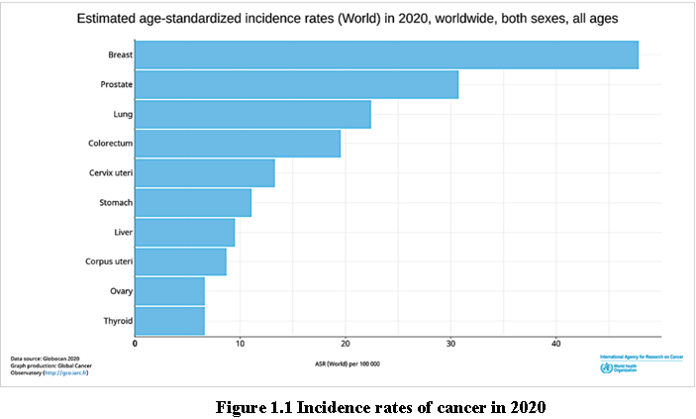

Thousands of females fall victim to breast cancer every year. The human body comprises millions of cells each with its unique function. When there is the unregulated growth of the cells it is termed as cancer. In this, cells divide and grow uncontrollably, forming an abnormal swelling tissue part called a tumor. Tumor cells grow and invade digestive, nervous and circulatory systems disrupting the bodies’ normal functioning. Though every single tumor is not cancerous. Cancer is classified by the type of cell that is affected and more than 200 types of cancers are known. This paper is focused on Breast cancer (BC).

Histopathological analysis remains the most widely used method for BC diagnosis and most of the diagnosis continues being done by pathologists. Applying visual inspection of histological samples under the microscope, automatic classification of histopathological images is a research topic that can make BC diagnosis faster and less prone to errors. The detection of breast cancer is done by the analysis of either mammography or ultrasound imaging and regular check-ups. Pathologists check the microscopic elements and tissue structure for detailed analysis.

Early detection of breast cancer through screening tests such as mammograms is an efficient way to maximize patients’ survival rate by treating the disease prematurely. However, no matter the expertise of radiologists examining mammograms, external factors such as fatigue, distractions and human error need to be minimized, as the rate of missed breast cancers during initial mammogram screenings are as high as 30% . To convey the complexity of mammogram interpretation, there are three different mammograms containing either normal or abnormal (benign and malignant) cases.

However, it has been proven that an early detection of breast cancer can significantly increase the chances of successful treatment plan and ensure a long-term survival of the patients [2]. Statistically, if the disease is detected and diagnosed at an early stage, nearly all (98%) patients will survive for five years or more, compared to around 1 in 4 (26%) people when the disease is diagnosed at a later stage [3]. According to the most common procedure, a ‘two-week wait’ is the procedure to diagnose breast cancer. The standard procedure to diagnose breast cancer by pathologists usually requires extensive microscopic assessment. Therefore, having an automated solution like a computer-aided diagnosis (CAD) system not only contributes to an easier diagnostic process, but also reduces the subjectivity in diagnosis.

Breast cancer varies based on which part of the breast tissue becomes cancerous. Commonly, breast cancer starts in the cells that line the ducts of the breast; however, it may also grow in different areas of the breast such as the lobules, milk ducts or sometimes in 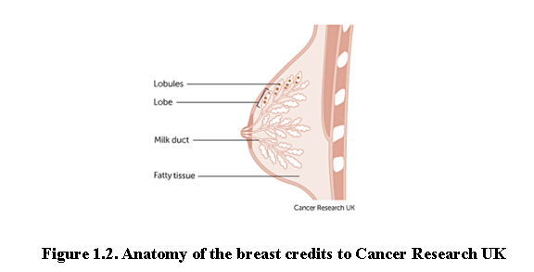between tissues, as illustrated in Figure 1.2 [4].

**Figure 1.2 Anatomy of the breast credits to Cancer Research UK**

The term ‘breast cancer’ refers to a malignant tumor that has developed from cells in the breast that are considered cancerous and cause danger to health. The stage of this cancer is usually expressed as a number on a scale of 0 through IV, with stage 0 describing non-invasive cancers that are still within their original location and stage IV describing invasive cancers that have spread outside the breast [5]. In cases where cancer is detected, but no cancer cells are visible in the lymph glands, the breast cancer is of a lower risk. When spreading occurs, it carries a substantial risk of death, meaning that the cancer cells from the breast tissue have broken away, which can be carried to nearby lymph nodes by the lymph fluid (fluid that gathers waste products and drains into veins to be removed) [5]. Figure 1.3 demonstrates the lymph nodes around the breast.

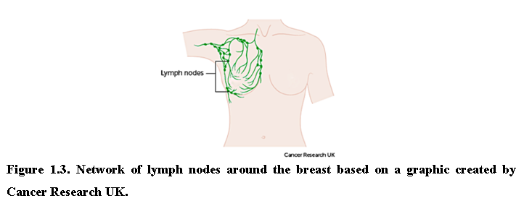

**Figure 1.3 Network of lymph nodes around the breast based on a graphic created by Cancer Research UK**

Breast cancer can be distinguished as benign (non-cancerous) and malignant (cancerous/metastatic) tumors. Benign tissue refers to changes in normal tissue of breast parenchyma, which does not relate to the development of malignancy [6]. Contrarily, malignant tissue can be categorized into two types: in-situ carcinoma and invasive carcinoma. Additionally, in some cases benign breast tumors can be further divided into four subclass types, adenosis, fibroadenoma, phyllodes tumor, and tubular adenoma, whereas malignant breast tumors can be further divided into ductal carcinoma, lobular carcinoma, medullary carcinoma, mucinous carcinoma, tubular carcinoma, and papillary carcinoma [7].

Histopathology (histology) image samples of breast lesions are obtained through either needles or surgical operation, which are then later processed and allocated to a glass slide to undergo a staining process. Hematoxylin and eosin (H&E) and immunohistochemistry (IHC) are the most used histopathology staining protocols. This development of scanners has digitalized histopathological tissue sections and turned digital pathology into a routine practice [8]. Currently, histopathological images play a vital role in cancer diagnosis because of the large amount of information they provide for medical image analysis [9]. Whole-slide images (WSI) can have multiple regions of breast lesion tissue, whereas microscopy images are patches derived from WSI, each representing one type of breast lesion only.

The motivation behind this project is to explore techniques for implementing a deep learning system that can accurately detect breast cancer in order to prevent late treatments due to false negatives as well as preventing unnecessary treatments in cases of false positives. Deep learning models are composed of large network of layers made up with neurons and perform classification by learning features internally. Generally, convolutional neural network (CNN) has been quite successful deep learning model for histopathological image analysis, especially for detection and classification.

**1.2 Traditional Clinical Procedure**

The traditional clinical proceedings for breast cancer are painful. Lymph nodes found in women's breasts might not always be a malignant tumor or cancer. A patient must undergo clinical examination by a breast surgeon then the result like x-ray mammography (Figure 1.4) an ultrasound scan (Figure 1.5) or MR mammography will be evaluated by a radiologist. If the report was suspicious, a needle biopsy is recommended followed by surgical removal of a lesion. The above procedure is very painful for women as they take a blood sample or a part of the lesion from the affected part. As it is most painful the pain stays for days to months. As per reports, diagnostic errors play a role in around 10% of patient deaths and breast cancer is no exception.

Research says, “Overall, screening mammograms miss about 20% of breast cancers that are present at the time of screening because mammograms cannot find the affected area for all skin types. False-negative results can delay treatment and a false sense of security for affected women”. On the other hand, false-positive results would let the patient go through unwanted painful and expensive procedures.

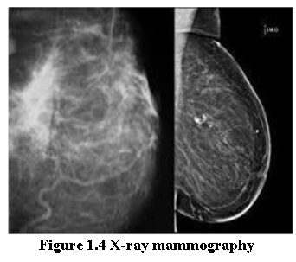

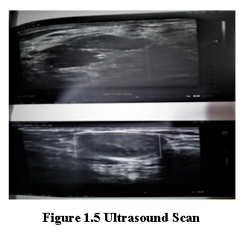

**1.3 Computer-Aided Diagnostic Expert Systems**

With the advanced development of artificial intelligence, many machine learning techniques have been applied for CAD systems. This technique can potentially outperform humans and learn more efficiently with time, therefore integrating machine learning in diagnosis can supply useful knowledge to assist pathologists in evaluating and analyzing enormous amounts of medical data [10]. It could also speed up the process due to the capability to process large data much faster than manual diagnosis by a pathologist [10]. Breast cancer diagnosis can be considered as a classification problem in machine learning, in which the result indicates which class of cancer it belongs to. Fundamentally, the main steps involved in developing the core of a computer-aided diagnosis (CAD) system for breast cancer are presented in Figure 1.6.

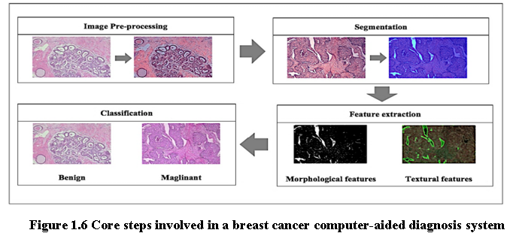

CAD systems have not only produced faster diagnosis results but have also emerged as an additional opinion to assist pathologists to avoid overlooking abnormal features. This automated solution can be explained in two sub-categories:

1. Computer-aided detection (CADe) systems, which detect cancer or metastatic tissue.

2. Computer-aided diagnosis (CADx) systems, which determine the distinct types of breast cancer.

There are two approaches in developing a CAD system which are the conventional method and deep learning method. The main difference between these two types of methods is that conventional CAD methods are a traditional approach of extracting the features from an image based on human-defined descriptors to perform classification. Deep learning CAD methods are types of automated learning that can discover representations of data automatically by transforming the input information into multiple layers of abstractions [11]. Figure 1.7 illustrates two methods for CAD systems.

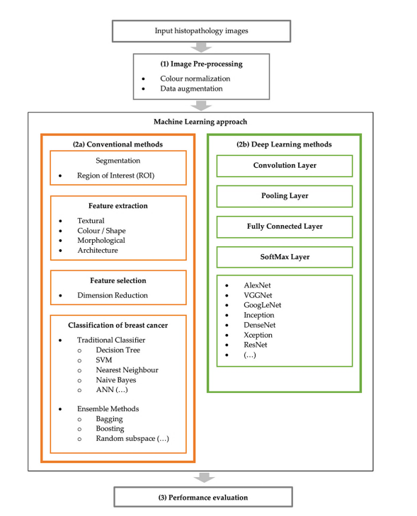

**Figure 1.7 Overview structure of methods for Breast Cancer detection in CAD systems**

**1.3.1 Image Pre-Processing**

Image pre-processing is an effective route to apply as data preparation at the first step to make raw data more suitable for further analysis. In the case of histopathology images, the most used pre-processing technique is color normalization because of the color variation obtained in these types of images and the powerful impact on the machine learning model. Data augmentation is another commonly used technique for a small dataset. In this section, the techniques of (1) color normalization and (2) data augmentation are presented.

* **Color normalization:** The inconsistent various appearances of stained sections is amongst the foremost challenges to analyze histopathological images [12]. This is because the samples are collected under various inconsistent conditions of tissue slices, preparation or image acquisition, noise arising, lightning conditions, and protocols of staining while capturing the digital image [12]. Therefore, these variations could produce samples with different color intensities [13]. Research studies [14] have shown the significant effect of stain normalization that enhances the performance of breast cancer classification. Here, a few color normalization techniques will be investigated by categorizing them into three types of method which are global color normalization, the supervised method, and the unsupervised method for stain separation.
* ***Global color normalization***: This method is suitable for histology images due to comprehensible values of autocorrelation coefficient or spatial dependency of pixel (intensity). This method separates color and intensity information using principal component analysis (PCA) [15]. Reinhard et al.’s method was one of the first techniques, which uses a simple statistical analysis to achieve color correction by comparing one image’s color boundaries and choosing it as an appropriate source image as a benchmark, applying it as characteristic to all the other images [15]. It uses an unsupervised method to heuristically estimate the absorbance coefficients for the stains for every image and the staining concentrations for every pixel to recompose the images [15].
* ***Supervised method for stain separation***: In this method, images are converted to optical density (OD) space due to Beer’s law [16] that suggests color stains act linearly in OD space, given in Equation (1).

V = log $( \frac{I0}{I} )$

where V represents the intensity in OD space, I represents the intensity in RGB space, and I0 represents the illuminating intensity incident on the sample [17]. Khan et al. proposed a method to use stain color descriptors to compute image-specific stain matrices for stain normalization [18]. Then, stain separation is applied to obtain different stain concentration values from the image and provide a nonlinear (spline based) mapping function; meanwhile all images will be replaced using the normalized stain channels [18].

* ***Unsupervised method for stain separation:*** Training is not required because it is expected to learn itself [19]. Macenko et al. first proposed a method to use singular value decomposition method (SVD) to obtain optical density of images to perform quantitative analysis-based color normalization [20]. Kothari et al. then proposed a method based on histogram specification using the quantile normalization based on distinct color channels obtain from images to match each image to the target image histogram color channels [21]. Bejnordi et al. later proposed an improved version which relies solely on color features; their algorithm makes use of spatial information to achieve robustness against severe color and intensity variations [22].
* **Data augmentation**: A data-space solution to the problem of limited data by enhancing the size of training datasets to generate a better learning model [23]. Tellex et al. showed that to obtain a particularly reliable performance of CAD system on histopathology images, color normalization should be used along with data augmentation [24]. This procedure will imply data wrapping and oversampling over the dataset to increase the sample size of the training dataset as a limited dataset and over fitting is a common challenge [25]. These processed include various image transformations to modify the image morphology. If we were to look at one image from a single perspective and make a determination, it is more likely to be prone to error compared to if we were to look at it from several perspectives to make the final determination. Taking this into breast cancer analysis, checking the image with several more perspectives provide a more confident and accurate answer to which class it belongs to. Thus, this procedure provides a broader interpretation to the original image.

**1.3.2 Deep Learning CAD Methods**

Following the recent advancements of deep learning (DL) that have shown a broad potential with state-of-the-art performance, many researchers have been approaching the process of feature extraction and selection using this automated technique. This improved approach combines learning and decision making by applying unsupervised learning upon different deep neural network architecture designs. It combines learning the features in histopathology images and classifying the images in one high complex architecture model. This process is often referred to as a black box and it can be complex to understand how deep learning works, i.e., how did the model come to this decision and what was involved in the learning process.

The deep learning approach is based on convolutional neural networks (CNN) to enable a deeper level of exploration and broaden the capability of a model to perform classification on breast cancer histology images. They are able to build a complex level of non-linear mapping of input and output by utilizing cascaded convolutional layers. They are considered as a unique type of neural network where instead of having weights for each input, the weights are shared and are convolved across the input as a moving window [26]. They are computational models that are composed of multiple processing layers to retrieve features from raw data with multilevel representations and hierarchical abstraction. A typical CNN consists of convolutional layer, activation function, pooling layer, and output layer. An example of a standard CNN model architecture with two feature stages is shown below in Figure 1.8[27].

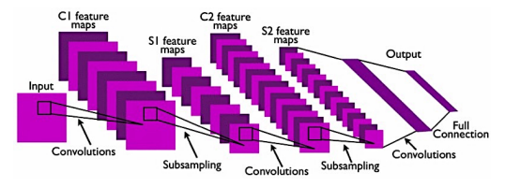

**Figure 1.8 Basic structure of a CNN architecture**

To simplify, convolution is a signal processing operation which easily computes as a discrete spatial processing operation [28]. Recently, there have been several popular deep-learning-based models that improved the CNN model, such as AlexNet [29], VGGNet [30], GoogLeNet [31], Inception [32], DenseNet [33], Xception [34], and ResNet [35]. There are two ways to implement the method: (1) training from scratch and (2) transfer learning.

**1.3.2.1 Training from Scratch**

This method requires a large amount of input on histopathology images of breast cancer to train the CNN model. It requires more effort and skills to achieve a reliable performance CNN model when it comes to selecting hyperparameters such as learning rate, number of layers, convolutional filters and more, which can be a challenging task. This implementation also requires a high GPU processing power to perform training as CNN training can be time consuming because of the complex architecture [36].

**1.3.2.2 Transfer Learning**

Most publicly available datasets for breast histology images are considered as small datasets for training a deep learning model, which can be highly prone to overfitting due to the inferior performance of generalizability. The transfer learning method provides a solution to this by performing transfer knowledge tasks on the model based on a source domain that provides a large amount of sample data to the target domain. Pre-trained models can sufficiently prepare the small-scale histology dataset in a deep learning model. It can be used to: (1) perform as a baseline model, which uses the architecture of the pre-trained network and builds the model from scratch by random initialization of weights [37]; (2) perform as a feature extractor, which extracts key features and the outputs which go into the convolutional base are fed directly to the classifier without modifying any weights or convolutional parameters[37]. and (3) perform fine tuning where weights will be passed into the designed network from the pre-trained network by fine tuning the layer or performing partial training of the network [37]. Figure 1.9 illustrates the transfer learning approach.

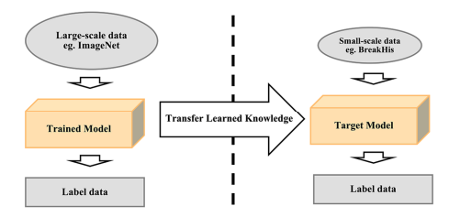

**Figure 1.9 Transfer learning approach**

**1.4 Causes and Symptoms of Breast Cancer**

**1.4.1 Causes of Breast Cancer**

* *Inheritance*: - Inherited genes from the family having breast cancer can be a cause for the patient.
* *Menopause*: - Beginning a period at younger (below 12) or older (after 55).
* *Radiation*: - If a patient had radiation treatment on the chest at a younger age.
* *Alcohol*: - Drinking alcohol can increase the rate of breast cancer.
* *LCIS*: - If Lobular Carcinoma in Situ (LCIS) in the breast, it can lead to breast cancer.
* *Gender*: - the probability is 100 times more in women than man
* *Hormone replacement*: - Hormone replacement is done to relieve from menopause but it causes a risk of breast cancer

**Other risk factors include:**

* High BMI after menopause: Weight gain after menopause increases the risk of cancer breast.
* Lack of exercise
* Radiation Therapy to the chest (before age 30)
* Hormonal use – postmenopausal
* Late pregnancy at an older age
* Race (African American-higher risk)
* High bone density

The risk factors of breast cancer are mentioned in figure 1.10.

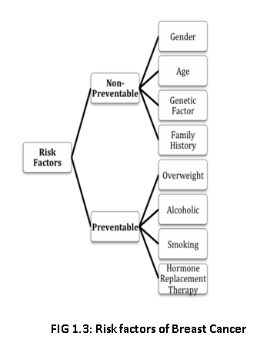

**Figure 1.10 Risk Factors of Breast Cancer**

**1.4.2 Symptoms of Breast Cancer**

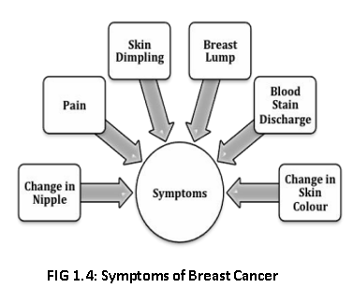

**Figure 1.11 Symptoms of Breast Cancer**

* Severe pain in the breast.
* Formation of painless breast lumps (hard mass with irregular edges but sometimes it can be soft ).
* Change in nipple i.e., retraction of nipple inward or discharge of nipple other than milk.
* Change in the shape and size of the breast.
* Change in the skin of the breast i.e., puckering or dimpling of the skin.
* Bloodstain discharge from the breast can also lead to breast cancer.
* Crusting, peeling of the pigmented area of skin surrounding the areola of breast skin.
* Causing small red holes over the skin of the breast.

Figure 1.11 describes the symptoms of breast cancer for self-diagnosis for a patient. If these symptoms are notified, it is better to contact the consulting doctor for further confirmation as early as possible. Neglecting these symptoms can cause risk for lives. Cancer surgery removes the tumor and nearby tissue during an operation. A doctor who treats cancer with surgery is called a surgical oncologist. Surgery is the oldest type of cancer treatment. And it is still effective for many types of cancer today.

**1.5 Types of Breast Cancer**

1. **Benign Breast Cancer (Non-Invasive):**

It is also known as carcinoma in situ. This type of cancer doesn't spread to neighboring tissue regions and hence is rarely a threat to life. These cells remain entirely in situ (in their place of origin) because they have not yet developed the ability to spread outside of these ducts, either within the breast or elsewhere in the body. The cancer cells most commonly develop inside the milk ducts and hence it is also known as Ductal carcinoma in situ (DCIS) cancer. Both men and women can develop DCIS.

1. **Malignant Breast Cancer (Invasive):**

Malignant or Invasive is the type in which cancer has the potential to spread from the breast to other parts of the body and is a threat to life. Often, they can be removed but sometimes grow back. The most common type of invasive breast cancer is invasive ductal cancer. This accounts for 80 % of all cases of breast cancer.

1. **Other types of Breast Cancer:**

The less common type of breast cancer includes invasive lobular breast cancer, which develops in the cells of the milk-producing lobules, inflammatory breast cancer, tubular breast cancer, medullary breast cancer, and papillary breast cancer.

**1.6 Diagnosis of Breast Cancer**

Breast cancer can be found after symptoms appear, but for many women, early breast cancer has no symptoms. Hence performing a screening test before any symptoms develop is very essential. Early detection of breast cancer (before the presence of symptoms), in the localized stage, increases the 5-year survival rate to 98 %. The tests that can be performed are classified into a triple assessment routine as shown in Figure 1.12. Breast cancers tend to be larger and more likely to be spread beyond the breast if symptoms are predominant. In contrast, breast cancer that is found during screening tests is more prone to be smaller and confined to the breast.

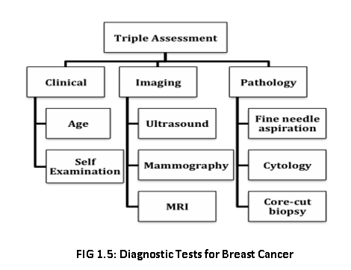

**Figure 1.12 Diagnostic Tests for Breast Cancer**

1. **Clinical: -**

* **Examination:** Women above a certain age and showing symptoms should have a physical exam to check for breast cancer. The breast is examined for lumps or suspicious areas (change in texture, size).

1. **Imaging:-**

* **Mammography:** It is an x-ray of the breast. It is used to diagnose women who have breast symptoms. A mammogram shows an abnormality in the breast, which includes lesions.
* **Ultrasound (Sonography):** The test uses the sound waves to outline a part of breast. It is usually helpful in women with dense breasts and is used to target a specific area found on the mammogram.
* **MRI (Magnetic Resonance Imaging):** This test used to detect breast cancer and other abnormalities in the breast. A breast MRI captures multiple images of your breast. Breast MRI images are combined using a computer to create detailed pictures.

1. **Pathology: -**

* **Biopsy:** This test involves taking a sample of tissue cells from the breast and testing to see whether it is cancerous or not. There are 2 main types of surgical biopsies:

1. An incisional biopsy removes a piece of the suspicious area to study.
2. An excisional biopsy removes the whole suspicious area, such as a mole or a lump.

* **Fine Needle Aspiration:** This test uses a thin hollow needle to withdraw a small amount of tissue (including fluids) from the breast and test it under the microscope to check whether cells are cancerous or not.
* **Cytology:** Diagnosing diseases by looking at single cells and small clusters of cells are called cytology or cytopathology.

**1.7 Treatment of Breast Cancer**

The prognosis and treatment of breast cancer depend on the stage of cancer and the type of breast cancer shown in Table 1.1. Breast cancer diagnosed at a later stage requires a different treatment than when diagnosed in its early stages. A patient may have one treatment or a combination. Figure 1.13 illustrates the treatment for breast cancer.

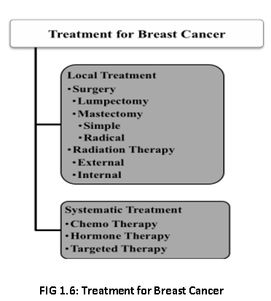

**Figure 1.13 Treatment of Breast Cancer**

**1.7.1 Local Treatment**

* **Surgery:** It either involves removing the cancerous lump (tumor), which is known as breast-conserving surgery or mastectomy that is the removal of the whole breast.
* **Radiation Therapy:** It involves controlled doses of radiation that are used to kill cancer cells. Usually given to a patient after surgery and chemotherapy to kill any residual cancer cells.

* + 1. **Systematic Treatment**
* **Chemotherapy:** It involves using anti-cancer drugs to kill cancer cells.
* **Hormone Therapy:** Breast cancer may be stimulated to grow by hormones estrogen or progesterone, which is naturally developed by the body. This treatment involves lowering the level of hormones in the body and reversing the effect.
* **Targeted Therapy:** Breast Cancer targeted therapy uses drugs that block the growth of breast cancer cells in specific ways. For example, targeted therapy may block the action of an abnormal protein (such as HER2) that stimulates the growth of breast cancer cells.

**Table 1.1 Stages in Breast Cancer**

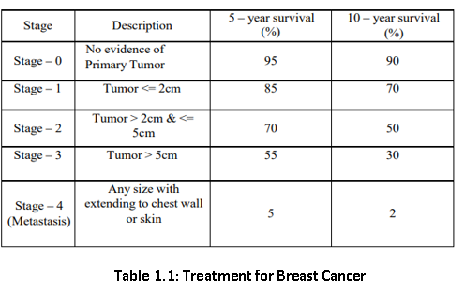

**1.8 Relevance of the project:**

Deep CNN diagnosis provides a second option for image diagnosis which can improve the reliability of experts’ decision making. Advanced CNN technology has achieved great success in natural image classification and it has been used widely in bio-medical image processing. Digitized tissue histopathology has now become responsive to the application for computerized image analysis.

**1.9 Scope of the Project**

* A Literature Review is a type of Review article. A literature review is a scholarly paper, which includes the current knowledge including Substantive findings, as well as theoretical and methodological contributions to a particular topic.
* Literature Reviews are often associated with academic-oriented literature, such reviews are found in academic journals and are not to be confused with book reviews that may also appear in the same publication.
* In the Existing system, traditional clinical procedures, causes and symptoms of breast cancer, diagnosis and treatment for breast cancer are discussed.
* Software requirement Specification is a fundamental document, which forms the foundation of the software development process. It not only lists the requirements of a system but also has a description of its major features.
* Analysis is the process of finding the best solution to the problem. System analysis is the process by which we learn about the existing problems, define objects and requirements and evaluate the solutions.
* Proposed methodology chapter covers the implementation aspects of the project, giving details of the programming language and development environment used. It also gives an overview of the core modules of the project with their step-by-step flow.
* Result and discussion chapter gives the result of the project and the snapshots of the project, its related information including graphs and other information of the output.
* The summary of the work carried, contributions if any, their utility along with the scope for further work.

**1.10 Problem Statement:**

In today’s scenario, we have too much delay and inaccuracy in the diagnosis results provided by clinical centers. There are many cases where patients are given wrong inputs regarding their diagnosis and face false-positive or false-negative results which results in either pouring the money unnecessarily or even paying for the death due to delay of treatment.

Most of these recent works related to BC classification are focused on Whole Slide Imaging (WSI). The broad adoption of WSI and other forms of digital pathology has been facing obstacles such as the high cost of implementing and operating the technology, insufficient productivity for high-volume clinical routines, and intrinsic technology-related concerns.

In order to overcome these disadvantages of traditional methodology, Our system proposes an easy approach for clinical examination for breast cancer diagnosis prediction. Convolutional layers learn from the features automatically. Higher accuracy results will be obtained than traditional methods, which also reduces the patient’s waiting time and increases the life rate of people.

**1.11 Organization of Thesis:**

The entire documentation is framed in the following manner as chapter 1 gives the introduction of our project, chapter 2 describes us the details about the literature survey. Chapter 3 describes about the system requirements specification, chapter 4 elaborates about the dataset, basic architecture of CNN and implementation of our project, chapter 5 gives us the results and discussion and finally chapter 6 gives us the conclusion and future scope.

**CHAPTER 2**

**LITERATURE REVIEW**

The computer-assisted diagnostic methodology for breast cancer IDC estimation in microscopic images is divided most commonly into microscopy images and Whole Slide Imaging (WSI). Literature suggests the use of the automated methodology for the classification of these images into a number of classes as per the available dataset. For microscopic images, one of the most widely expressed concepts is to do binary classification for histology images as benign or malignant. Meanwhile, to classify with machine learning, the model requires certain features for which nuclei features were considered as the most appropriate features [38]. Besides color-based segmentation approach for nuclei detection as discussed in [38], some other approaches for nuclei segmentation based on transformation are presented in [39]. All these methodologies use the segmented Region-of-Interest (ROI) to extract features like texture and topological information. Using Machine learning with extracted features the accuracy claimed lies in between 72 and 97% [38, 39].

But most of the literature provides an alternative solution for extraction of handcrafted features, which requires a lot of human intervention and heuristic knowledge, and that is the use of deep learning models based on convolutional neural networks (CNNs). One such approach is discussed in [40] for the classification of the breast histology images using patch information. The proposed approach is tested with different resolution images of the breast dataset [41] to gain the classification accuracy of 84%.

Besides the binary classification problem, several works exist that focused on multiple class classification problems. A complex classification of three class problem using a hybrid feature set of curvelet transform and local binary patterns with support-vector machines (SVM) and Neural Network classifier is presented in [42]. Another approach based on handcrafted features for four class problem is presented in [43]. Here the author used three types of feature sets including nuclei, color regions, and textures with an SVM classifier. But the claimed classification accuracy is not improved a lot. Further, a deep model over this dataset is proposed that used a CNN architecture named VGG for the classification of the histology image patches [44]. Moreover, the work presented in [45] refers to the use of the multi-size and discriminative patches of histology images classification using a deep model. This automated feature extraction property of deep models made it a preferred choice over traditional machine learning models as they have attained tremendous gain in classification accuracy over other methods.

While reading literatures it was observed that most of them consist of direct implementation of CNN after some pre-processing, however, some of the literature exist that include a slight modification in the existing CNN architecture as per the problem specification. Literature also exists where experimentation is done based on different combinations of CNN architectures, known as hybrid or ensemble methodology for enhancing recognition rate [46, 47]. One of the ensemble methods of deep architectures is presented in [48] where ImageNet based pretrained model with CaffeNet deep architecture is used for breast histology image classification. A Spatially Constrained CNN based architecture was proposed in [49] which regresses the likelihood of a pixel of an image to be at the center of a nucleus.

To classify nuclei, they came up with a neighboring ensemble predictor method to predict the class label of the detected nuclei. Some of the methods, other than microscopic images, which were used in the classification of the histology WSI using CNN exist in literature. In [50], the author proposed a methodology that handles large-sized images for classification without using nuclei ROI segmentation. The author used the ensemble CNN architectures with quasi-Monte Carlo adaptive sampling methodology for invasive cancer cell classification. A two-tier stack-based approach for binary classification to multi-class problem was proposed in [51]. While other methods which use the deep CNN architecture for WSI histology image classification based on multi-class classification is given in [52].

There also exist certain literature works that focus on the data aggregation problem. One such approach was proposed in [53] that handles data aggregation problem through crowdsourcing layer which is considered as a learning process of CNN. The proposed idea is to set the learning process with the same architecture on various CNNs models with distinct image scales. Some of the other methods which are the extended forms of traditional CNN architecture and present in literature for classification of the histology images were given as: In [54] a methodology was proposed that builds Fully Connected Network (FCN) that take inputs of any random size and produce outputs of the corresponding size with learning and inference. Author(s) also adopted traditional classification networks like AlexNet, VGG, and GoogleNet into FCNs and used transfer learning. A novel Bilinear Convolutional Neural Network (BCNN) based algorithm was proposed for classifying the histopathological images in [55]. The claimed results were found superior to the ones found using normal CNN. A Bilinear Convolutional Neural Network (BCNN) consists of two individual CNNs whose outputs of the convolutional layer are multiplied with the outer product at each spatial location. The main advantage of BCNN is that each entity of one network is combined with each other entity of the network.

One of the major drawbacks in all of the above deep models is that they suffer from vanishing gradient problem. While working with a greater number of hidden layers and with a large dataset, during learning process the backpropagation methodology is adapted. Backpropagation results in generating gradients with respect to initialized weight and bias. As the network compute loss layer-by-layer, it is found that at each layer while moving backward, the gradients tend to decrease gradually. It reflects that the neurons in the former layers will learn very slowly in comparison with layers formed at last in the deep model.

Qiwen Xu et al. [56] proposed a CAD system based on CNN using a diffuse optical tomography system. This architecture contains 5 layers, two convolutional layers, two batch normalization, and one fully connected layer. It obtains 90.2% accuracy, 0.80 specificity, and 0.95 sensitivity for the dataset of a total of 1260 2D grayscale images. He Ma et al. [57] developed a CNN architecture based on the Fus2Net classification method. It is evaluated with a dataset of 100 Breast ultrasound tumor images and achieved 92% accuracy, 88.89% specificity, and 95.65% sensitivity. These results are closest to the fine-tuning ML method. Rashmi et al. [58] summarized the recent state-of-the-art methods for the classification of breast cancer histopathological images. Md ZahangirAlom et al.[59] proposed a breast cancer classification method using Inception Recurrent Residual Convolutional Neural Network and it provides superior classification performance of 2.14% improvement compared to existing machine learning and deep learning-based approaches.For the prediction of breast cancer, deep convolutional neural networks may be used to mimic human decision-making. Alexander et al.[60] implemented a Deep Convolutional Neural Network (DCNN) using a sliding window approach and reached the accuracy of 93% in the breast lesions classification. To get a robust evaluation for DCNN, special care needs to take for balanced data set generation.

Kadir Can Burcak et al. [61] use parallel computing architecture with Cuda-enabled GPU to train the model with less hardware and in a short period with the best performance. Heqing Zhang et al.[62] constructed a different prediction model using CNN based on InceptionV3, VGG16, ResNet50, and VGG 19 and AUCs achieved were 0.905, 0.866, 0.851, 0.841 respectively. Ankit Vidyarti et al. [63] proposed a model with 9 layers of deep dense architecture. It uses Densenet-169 to find an accuracy of 98.21%.VenubabuRachampudi et al. [64] introduced a classification system of histopathological images using an image data set of RGB-colored images belonging to 8 different classes. It attains the lowest error rate of 22.7% as compared to machine learning methods. The error rate can be further reduced by the modifications of different layer combinations.

Huh et al. [65] introduce a probabilistic model for microscopic images at two stages with the proposed method. The first stage entails the identification of spatio-temporal patch sequences, while the second one involves the localization of a birth event. Albarqouni et al. [66] propose a network model (AggNet) from crowds for mitosis detection in breast cancer histology images. AggNet is a learning model that handles data aggregation directly as part of the learning process of the convolutional neural network. Bejnordi et al. [67] compared the metastases detected at the clinic with the results of deep learning-based systems. They report that 27.6% of the metastases are misdiagnosed by the pathologists, while the CNNs achieved better diagnostic performance.

Filipczuk et al. [68] classify the feature vectors through a support vector machine with a set of 25 features, based on the analysis of cytological images of fine needle biopsies using the circular Hough transform. They achieve 98% effectiveness in classification of tumor cells. Saha et al. [69] propose a supervised model to detect mitosis signature from breast histopathology WSI images, using deep learning architecture with handcrafted features. Their deep learning architecture mainly consists of five convolution layers. The model uses morphological, textural, intensity features and has 90% F-score. George et  al. [70] proposed a diagnosis system for breast cancer based on the nuclei segmentation of cytological images, using different machine learning models such as neural networks and support vector machines. They report accuracy rates ranging from 76 to 94% on a data set of 92 images.

Spanhol et al. [71] achieve a success rate of 90% at most by using BreakHis data set for histopathological images taken with different enlargement factors by classifying the cancer cells via deep learning methods. Han et al. [72] achieve an accuracy rate of 93.2% over BreakHis data set by using a diferent deep learning model recently proposed for grouping the breast cancer into multi-classes. Kausar et al. [73] proposed a binary and multiclass classification for breast histopathological images using a deep convolution neural network with Haar wavelet decomposed images. The proposed CNN model extracts and incorporates the deep features from 2-level Haar wavelet decomposed images. On BreakHis data set, this model showed an accuracy of 98.2% for both 4-class nd 2-class recognition. Togacar et al. [74] proposed a new CNN model (BreastNet) for breast histopathological image classification using the BreakHis data set. The proposed model showed an accuracy of 98.8% for classification.

Yang et al. [75] proposed an ensemble of multi-scale convolutional neural networks (EMSNet) to classify hematoxylin–eosinstained breast histopathological microscopy images into four categories, including normal tissue, benign lesion, in  situ carcinoma, invasive carcinoma. They used the training patches cropped and augmented at each scale to fine-tune the pre-trained DenseNet-161, ResNet-152, and ResNet-101. They found that a combination of three fine-tuned models is more accurate than other combinations. The proposed EMS-Net model showed an accuracy of 91.75±2.32% in the fivefold cross-validation using 400 training images.

Budak et al. [76] introduced an end-to-end model (Bi-LSTM) based on fully convolutional network (FCN). They used the FCN as an encoder for feature extraction and turned the output of the FCN to a one-dimensional sequence. High-resolution images were thus used as direct input to the model. The proposed model achieved a performance of 98.10% through the fivefold cross-validation technique. Dabeer et al. [77] proposed a new CNN model for binary classification of breast histopathological images using the BreakHis data set. They obtained a prediction accuracy of up to 99.86%. Vo et al. [78] proposed an approach that utilizes deep learning models with convolutional layers to extract the most useful visual features for breast cancer classification. This deep learning model is based on a novel boosting strategy to extract better features than handcrafted feature extraction approaches.

In our work, the DenseNet-201 pre-trained model is utilized as our first feature extractor. The transfer learning provides a lot of advantages. As the training is not required, it consumes less amount of time and requires less computational power. It doesn’t require large amount of data, as the model is already trained. DenseNet consists of a total 201 layers where each layer is arranged in such a way that it can solve overfitting issues while dealing with a small dataset. Besides, the DenseNet-201 model provides significant enhancements to the ImageNet database by solving the gradient descent problem. Compared to AlexNet, GoogleNet, ResNet architectures, the DenseNet-201 pre-trained model will derive more complicated and essential features as more deep CNN layers are included in this architecture.

**CHAPTER 3**

**SYSTEM REQUIREMENTS SPECIFICATION**

System requirements Specifications (SRS) forms the foundation of the software development process. SRS not only lists the requirements of a system but also has a description of its major feature. The SRS functions as a blueprint for completing a project with as little cost as possible. It is basically referred to as a “parent” document, because all subsequent project management documents, such as design specifications, statements of work, software architecture specifications, testing and validation plans, and documentation plans, are related to it.

The SRS functions as a blueprint for completing a project. The goal of preparing the SRS document is to:

* Facilitate communication between the customer, analyst, system developers, maintainers.
* To form a foundation for the design phase.
* Support system testing facilities.
* Controlling the evolution of the system
  1. **Functional Requirements:**

Functional Requirement defines a function of a software system and how the system must behave when presented with specific inputs or conditions. These may include calculations, data, manipulation and processing and other specific functionality. In this system following are the functional requirement: -

* Training dataset must be loaded

**3.2 Non-functional Requirements:**

Non-functional requirements are the requirements which are not directly concerned with the specific function delivered by the system. They specify the criteria that can be used to judge the operation of a system rather than specific behaviors. They may relate to emergent system properties. Non-functional requirements for this system are specified as follows:

* Responsiveness of the system needs to be appropriate since timely retrieval of sensitive health data is essential.
* The software utilized should be portable so that medical institutions can easily expand to their inter-connected hospitals, spread across locations.
* Privacy of sensitive data should always be maintained and must not be misused in any manner.
* Researchers requesting for data must be from authorized sources. Proof of consent is a responsibility that is borne by the medical institution where the health data is generated.
  1. **Hardware Requirements**
* Intel i5 processor
* Memory and disk space required: 1GB RAM + 1GB of disk + .5 CPU core.
  1. **Software Requirements**
* Jupyter Notebook: Jupyter Notebook (formerly IPython Notebooks) is a web-based interactive computational environment for creating notebook documents. It is an open-source web application that allows data scientists to create and share documents that integrate live code, equations, computational output visualizations, and other multimedia resources along with explanatory text in a single document. It supports 40 programming languages Julia, Python, R, Scala etc.
* Languages : Python
* Libraries: keras, numpy, os, math, json, PIL, matplotlib, pandas, sklearn, scipy, functools, collections, tqdm, tensorflow.
* Operation system : windows

**CHAPTER 4**

**PROPOSED METHODOLOGY**

**4.1 Data Set Description:**

The BreakHis dataset is publicly available and is commonly used to study the breast cancer classification problem. This dataset contains 7909 samples each falling within two main classes: benign or malignant. The benign subset contains 2440 samples and the malignant subset contains 5429 samples. The samples are collected from 82 patients with different magnification factors including ×40, ×100, ×200, and ×400. Some of the example images with a ×400 magnification factor is shown in Figure4.1. Each class has four subclasses; the four types of benign cancer are adenosis (A), fibroadenoma (F), tubular adenoma (TA), and phyllodes tumor (PT). The four subclasses of malignant cancer are ductal carcinoma (DC), lobular carcinoma (LC), mucinous carcinoma (MC), and papillary carcinoma (PC).

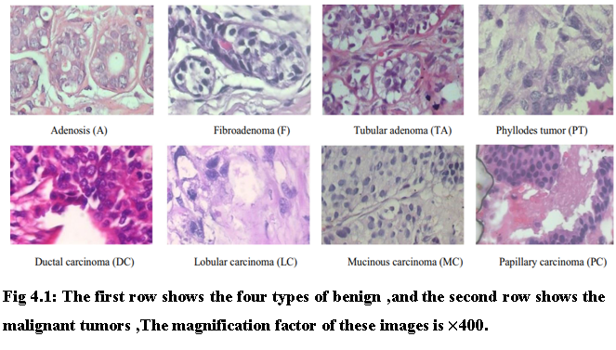

**(a)**



**(b)**

**Figure 4.1 (a) Types of Benign tumor (b) Types of Malignant tumor**

**4.2 Preliminaries**

**4.2.1 Input Layer**

Input images are matrices of square pixels which are in the shape of [WIDTH, HEIGHT, CHANNELS]. Let’s take our input as [224×224×3].

**4.2.2 Convolutional Layer**

The convolutional layers are the layers where filters are applied to the original image, or to others. Example is shown in Figure 4.2. Feature maps in a deep CNN. This is where most of the user-specified parameters are in the Network. The most important parameters are the number of kernels and the size of the kernels. The convolutional layers are the major building blocks used in convolutional neural networks.

The convolutional layer computes the convolutional operation of the input images using kernel filters to extract fundamental features. The convolutional layer is the core building block of a CNN. Convolutional layers are the layers where filters are applied to the original image, or to other feature maps in a deep CNN. This is where most of the user-specified parameters are in the network. Convolutional Neural Networks (CNN) are complex feed forward neural networks. CNNs are used for image classification and recognition because of its high accuracy.

* The process is a 2D convolution on the inputs.
* The “dot products” between weights and inputs are “integrated” across “channels”.
* Filter weights are shared across receptive fields. The filter has same number of layers as input volume channels and output volume has same “depth” as the number of filters.

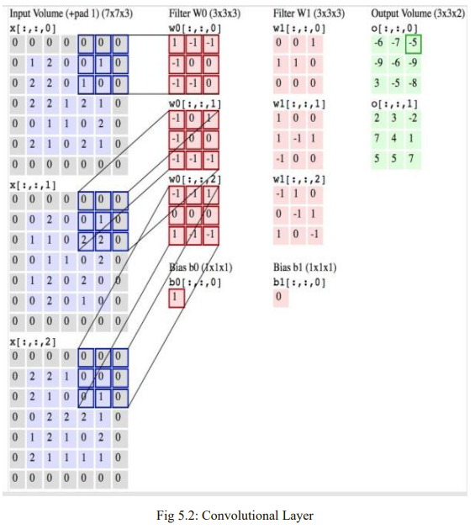

**Figure 4.2 Convolutional Layer**

**4.2.3 Filters**

A convolution is how the input is modified by a filter. In convolutional networks, multiple filters are taken to slice through the image and map them one by one and learn different portions of an input image.

As a result, we see an image where only dark edges are emphasized. As shown in the figure 4.3, the reading of the input matrix begins at the bottom right of the image. Next the software selects a smaller matrix there, which is called a filter. Then the filter produces convolution that moves along the input image. The filter’s task is to multiply its value by the original pixel values. All these multiplications are summed up. One number is obtained in the end. After passing the filter across all positions, a matrix is obtained, but smaller than an input matrix.

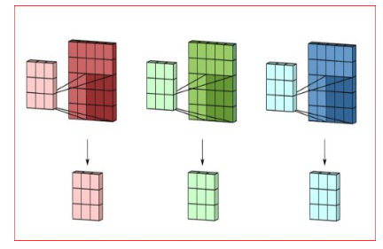

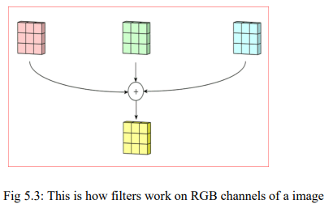

**Figure4.3 Filters work on image RGB channels**

The network will consist of several convolutional network mixed with non-linear and pooling layers. When the image passes through one convolution layer, the output of the first layer becomes the input for the second layer. And this happens with every further convolutional layer.

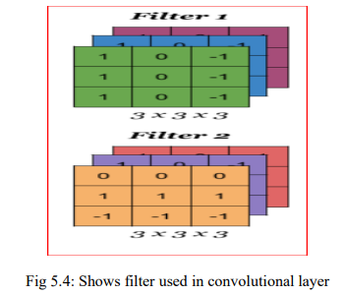

**Figure 4.4 Filter used in convolution layer**

The nonlinearity is added after each convolution operation. It has an activation function, which brings nonlinear properties. Without this property a network would not be intense and will not be able to model the class label. The filter used in convolution layer is shown in Figure 4.4.

The pooling layer follows the non-linear layer. It works with the width and height of the image and performs operations on them. As a result, the image volume is reduced. After completion of a series of convolutional, non-linear and pooling layers, it is a fully connected layer. The layer takes the output information from convolutional networks to the end of the network and results in a N dimensional vector.

**4.2.4 Dropout Layer**

Simply implementing dropout, the most popular regularization technique for deep neural networks, in any CNN has been proven to boost the accuracy by 1 to 2% at the cost of training time, even for state-of-the-art neural networks tested on large datasets like ImageNet. Despite training times being increased by 2 to 3 times, the gains in accuracy compensate for the extra time required to train the models implementing dropout.

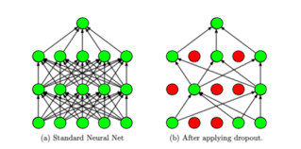

1. **(b)**

**Figure 4.5 a. Standard Neutral Net b. After applying dropout.**

Dropout works by randomly ignoring neurons in any layer (except the output layer) during the forward and backward passes of training, including its input and output connection weights, which helps prevents neurons from co-adapting too much with their neighbors and overfitting the data as they now have to be useful on their own which can be observed in Figure 4.5. Essentially, new thinner networks are created at each training step, and identical networks will never be sampled in the same training phases as there are 2N possible networks, where N is the number of droppable neurons.

The number of neurons dropped in a layer is controlled by the dropout rate hyperparameter p, dictating the probability of a neuron being dropped. During testing, the neurons are no longer dropped, and an averaged ensemble of all the thinner trained networks is used. This leads to models that generalize better thanks to neurons that are less sensitive to noise and small changes in the input.

**4.2.5 Pooling Layer**

Pooling layer is another building block of a CNN. Its function is to progressively reduce the spatial size of the representation to reduce the number of parameters and computation in the network. Pooling layer operates on each feature map independently.

Pooling layers provide an approach to down sampling feature maps by summarizing the presence of features in patches of the feature map. Two common pooling methods are average pooling and max pooling that summarizes the average presence of a feature and the most activated presence of a feature respectively. Fully connected layer and Global Average Pooling layers are shown in Figure 4.6.

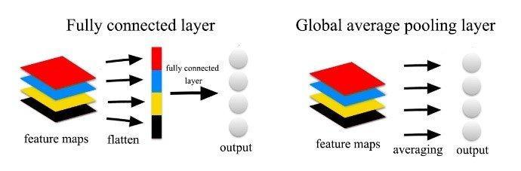

**Figure 4.6 Fully Connected and Global Average Pooling layer**

As shown in the figure 4.7, consider the max pooling with 2x2 window and stride 2, maximum value in that stride is 2, in the next stride, the maximum value is 1. Then the maximum value 3 is followed by 1.

By combining these maximum values, a new matrix is formed, which has been reduced in the size of the presentation to reduce the number of parameters and computation in the network.

* Convolutional layers provide activation maps.
* Pooling layer applies non-linear down sampling on activation maps.
* Pooling is aggressive (discard info); the trend is to use smaller filter size and abandon Pooling.

The addition of a pooling layer after the convolutional layer is a common pattern used for ordering layers within a convolutional neural network that may be repeated one or more times in a given model.

The pooling layer operates upon each feature map separately to create a new set of the same number of pooled feature maps.

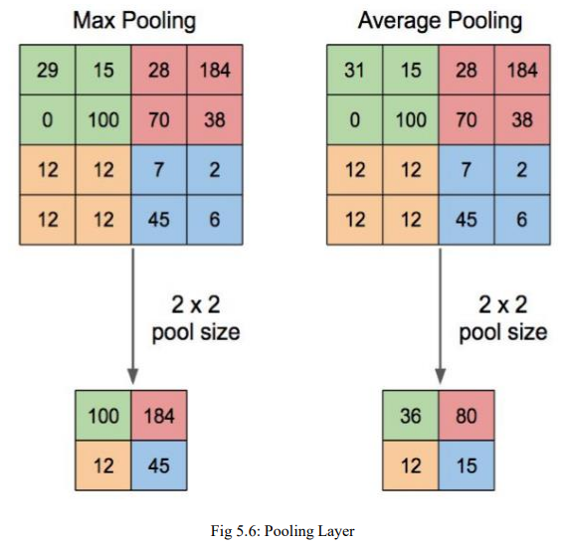

**Figure 4.7 Pooling Layer**

**4.2.6 Flatten Layer**

Flattening is used to convert all the resultant 2-Dimensional arrays from pooled feature maps into a single long continuous linear vector. The flattened matrix is fed as input to the fully connected to classify the image.

**4.2.7 Fully Connected Layer**

Fully Connected Layer is simply, feed forward neural networks*.*Fully Connected Layers form the last few layers in the network. The input to the fully connected layer is the output from the *final* Pooling or Convolutional Layer, which is flattened and then fed into the fully connected layer.

**4.3 Implementation**

The implementation phase of the project is where the detailed design is actually transformed into working code. Aim of the phase is to translate the design into the best possible solution in a suitable programming language. This chapter covers the implementation aspects of the project, giving details of the programming language and development environment used. It also gives an overview of the core modules of the project with their step-by-step flow. The implementation stage requires the following tasks.

1. Careful planning.
2. Investigation of the system and constraints.
3. Design of methods to achieve the changeover.
4. Evaluation of the changeover method.
5. Correct decisions regarding selection of the platform
6. Appropriate selection of the language for application development

Convolutional Neural Networks (CNN's) can automatically learn from the features and classify the images. From the dataset, 80% of data is taken as a training group, and the remaining 20% of data is taken for a testing group. A typical CNN has a convolutional layer, activation function, pooling layer, fully connected layer, and output layer.

The proposed CNN model is implemented through the Keras library, which is open-source software. Jupyter notebook IDE and the computer programming language Python are used. Load the necessary libraries like numpy, keras, tensorflow, matplotlib, sklearn, itertools etc. After loading the images into the respective folders, an array of zeros is created for labeling benign images and an array of ones are created for labeling malignant images.

Split the dataset into training and testing using the train_test_split() method and apply the to_categorical() method to transform the data before passing into our CNN model for training. It is used to convert the classes into a set of numbers in proper vector form for compatibility with the models. It is mainly done in classification problems.

The batch size used in our project is 16 and trained our model for 20 epochs. Batch size is the example of the most fundamental hyperparameters to harmonize in deep learning. Larger batch size used to train the model as it concedes computational speed ups for the affinity of GPUs. However, it is well comprehended that too high of a batch size will commence to lousy generalization. On the other hand, accepting smaller batch sizes has given faster convergence to great results.

The downside of using a smaller batch size is that the model is not guaranteed to converge to the global optima. Therefore, it is often advised that one starts at a small batch size reaping the benefits of faster training dynamics and steadily grows the batch size through training. The data augmentation is also done here. The practice of data augmentation is an effective way to increase the size of our training set. Augmentation of the training examples allow the network to be more diversified, but still representative data points during training. Then a data generator is created to get the data from our created folders into Keras in an automated way. Keras provides convenient python generator functions for this purpose.

The next step is to build our model. DenseNet201 is used as the pre-trained weights which are already trained in the ImageNet competition. DenseNet-201 is a convolutional neural network that is 201 layers deep. CNN layers are used to learn the features from input data. The chosen learning rate chosen is 0.0001. On top of it, the Global Average Pooling layer is used followed by 50% dropouts. To solve the issue of overfitting, we use two dropout layers. The first dropout layer will exclude 50% of the data and second dropout layer will exclude 20% of the data during training the model.The learned features are reduced by the pooling layer, integrating them into a few important elements. As the CNNs learn quickly, dropout layers are used to slow down the learning process and also help to prevent Neural networks from overfitting. The Figure 4.8 shows Pre-Trained DenseNet201 Model.

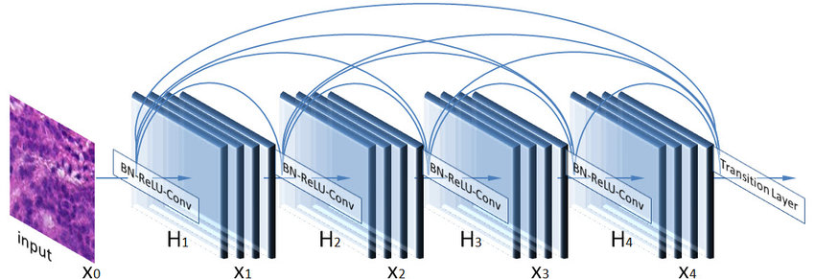

**Figure 4.8 Pre-Trained DenseNet201 Model**

Batch Normalization layer is used after completion of CNN layers and pooling, the learned features are flattened by converting the data into a single long feature vector and then passed through a fully connected layer. Each neuron in the previous layer is connected to all neurons in the next layer using a fully connected layer. The architecture of proposed CNN is shown in Figure 4.9.

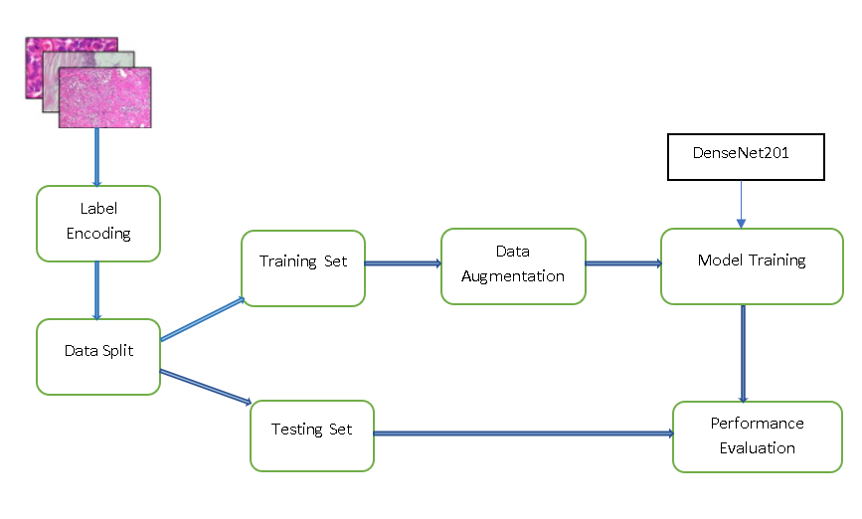

**Figure 4.9 The architecture of proposed CNN**

Several preprocessing steps have been employed before feeding the images into the fine-tuned transfer learning model which is shown in Figure 4.10.

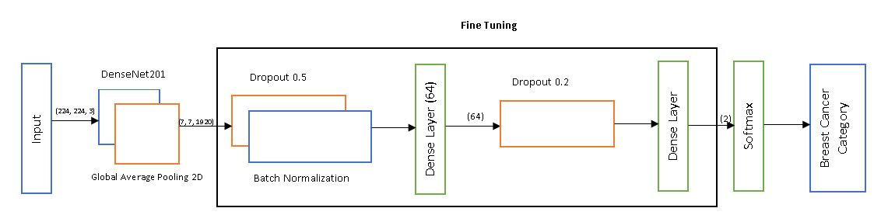

**Figure 4.10 Proposed Novel CNN framework**

Finally, the output layer is used to make a prediction. The dense layer is with 2 neurons for the 2 output classes i.e., benign and malignant with softmax as the activation function. Here the Dense block is used to reduce the dimensionality of the feature map. The feature maps indicate the number of times the input is interpreted/processed. The optimizer Adam and the loss function binary-cross-entropy is used. Adam optimizer to update the weights of the proposed dense model.

**4.4 Evaluation Metrics**

**Accuracy:**

It is the percentage of correct classification rate.

Accuracy = $\frac{True Positive+True negative}{Number of samples}×100$

**Recall:**

It is the number of correct positive results divided by the number of all relevant samples (all samples that should have been identified as positive).

Recall = $\frac{True Positive}{True Positive +Flase Negative}$

**Precision:**

It is the number of correct positive results divided by the number of positive results predicted by the classifier.

Precision = $\frac{True Positive}{True Positive +Flase Positive}$

**Confusion Matrix:**

It gives the output as a matrix and describes the complete performance of the model. There are 4 important terms:

* True Positives: - When a case was positive and predicted positive.
* True Negatives: - When a case was negative and predicted negative.
* False Positives: - When a case was negative and predicted positive.
* False Negatives:- When a case was positive and predicted negative.

**F1 Score:**

Together, precision and recall can be combined into a more concise metric, the F1 score, which corresponds to the harmonic mean of precision and recall. To achieve a high F1 score, both precision and recall must be high (unlike a regular mean) because as the precision goes down, the recall goes up, and vice versa, making the F1 score a reliable metric for evaluating a classifier since a balance between precision and recall must be found.

F1-Score **= $\frac{True Positive}{True Positive + \frac{1}{2} (Flase Positive+Flase Negative)}$**

**Roc-Auc Curve**:

It is a performance measurement for the classification problems at various threshold settings. ROC is a probability curve and AUC represents the degree or measure of separability. It tells how much the model is capable of distinguishing between classes. Higher the AUC, the better the model is at predicting 0 classes as 0 and 1 classes as 1. By analogy, the Higher the AUC, the better the model is at distinguishing between patients with the disease and no disease.

**CHAPTER 5**

**RESULTS AND DISCUSSION**

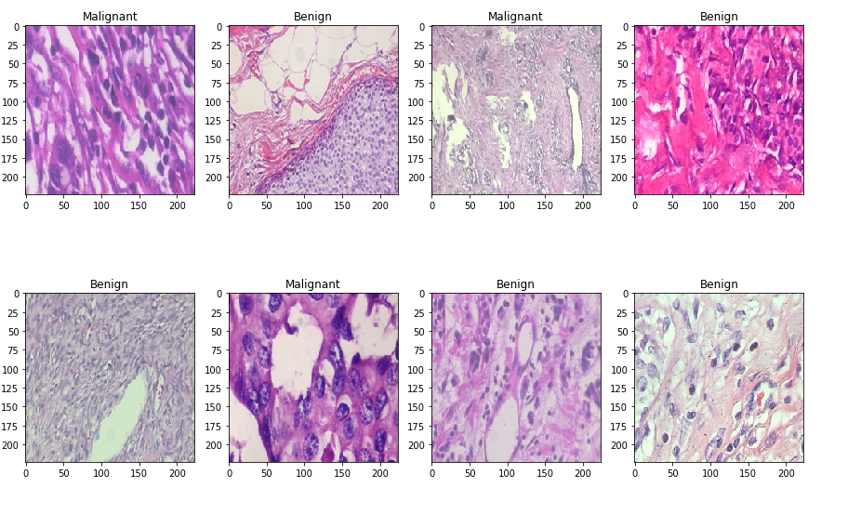The overall accuracy for breast cancer diagnosis achieved equal to 99.75%.The dataset showed improved accuracy obtained by CNN when compared to traditional learning techniques. Deep CNN diagnosis provides a second option for diagnosis which can improve the reliability of expert decision making. The Figure 5.1 has some input sample benign and malignant images.

**Figure 5.1 Input samples**

Output shape and the parameters involved in each layer is shown in figure 5.2. It shows how the input size is decreasing in each layer i.e., input layer, densenet201 layer, global average pooling layer.

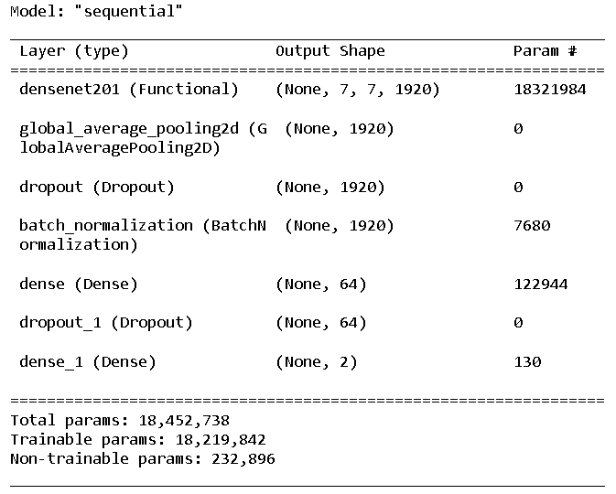

**Figure 5.2 Output of Densenet201 model**

Figure 5.3 consists of accuracy achieved for each of the epoch values. For each epoch value, the accuracy achieved is different. For epoch=20, the maximum accuracy achieved is 99.75%.

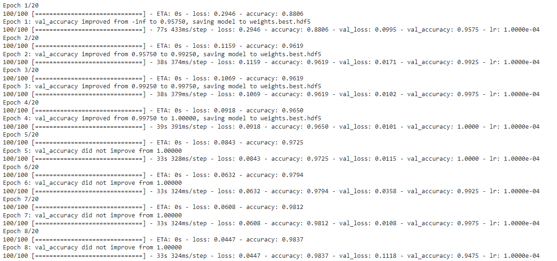

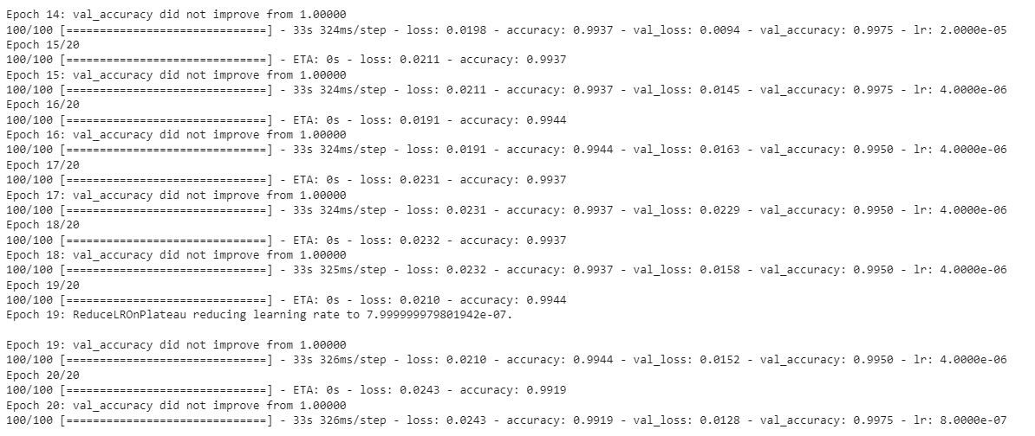

**Figure 5.3 Obtained Accuracy**

The Figure 5.4 is the accuracy graph obtained from the achieved accuracies. As we can see, the training accuracy is at its peak, which shows the maximum result. Once it becomes constant, the maximum result is taken.

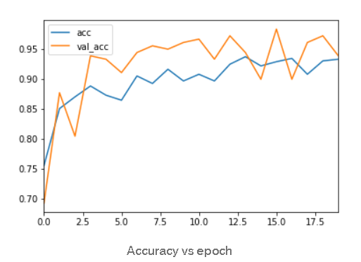

**Figure 5.4 Accuracy graph**

The graph shows loss in training and validation in Figure 5.5.

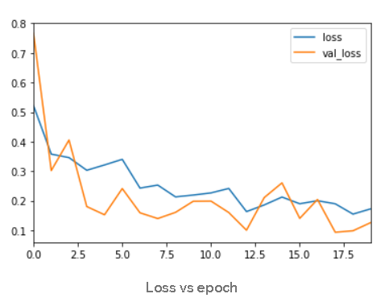

**Figure 5.5 Loss graph**

The obtained confusion matrix is shown in figure 5.6. From the confusion matrix gives results for True Positives, True Negatives, False Positives and False Negatives. These parameters are used in the evaluation of specificity, sensitivity and accuracy

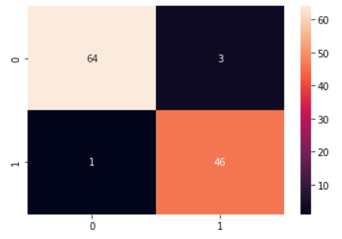

**Figure 5.6 Confusion matrix**

The obtained ROC-AUC Curve is shown in Figure 5.7.

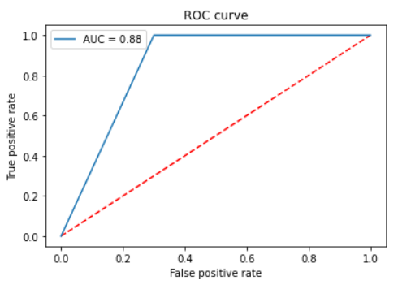

**Figure 5.7 ROC- AUC curve**

Below Table 5.1 gives the results for performance metrics. Figure 5.8 shows predicted vs actual results for 8 images. Table 5.2 is used to compare the results obtained in proposed method and previous methods.

**Table 5.1 Final results**

| **Accuracy** | **Precision** | **Recall** | **F1-score** | **ROC-AUC** |
| --- | --- | --- | --- | --- |
| 99.75% | 0.93 | 0.97 | 0.95 | 0.88 |

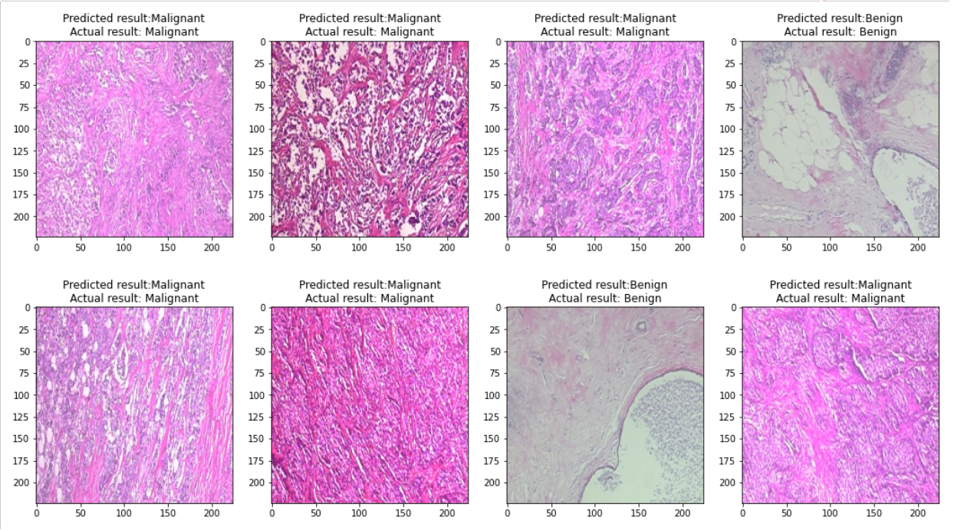

**Figure 5.8 Predicted result vs Actual result**

**Table 5.2 Comparison of Proposed model for breast cancer detection with previous methods**

|  |  |  |  |  |  |
| --- | --- | --- | --- | --- | --- |
| **Reference** | **Year** | **Dataset** | **Classification Type** | **Methods** | **Results** |
| Spanhol [34] | 2016 | BreakHis | Multi-Class | SVM, Random Forest, QDA, Nearest Neighbour | Accuracy: 80% - 85% |
| Asri [87] | 2016 | Wisconsin Dataset | Binary | SVM | Accuracy:97.13% |
| Rakhlin[88] | 2018 | BACH | Binary and Multi-class | ResNet-50 | Accuracy: 87.2%(for binary)  93.8%(for multi) |
| Spanhol[41] | 2017 | BreakHis | Multi-class | Modified AlexNet | Accuracy: 81.5%-86.3% |
| Nguye[71] | 2019 | BreakHis | Multi-class | Inception and ResNet CNN | Accuracy: 96.4% |
| Kassani[89] | 2020 | BACH | Binary | Pretrained VGG19, MobileNet, DenseNet with Multi-Layer Perception | Accuracy:92.71%  Precision: 95.74%  Recall: 89.80%  F1-score: 92.43% |
| Alkassar[90] | 2021 | BreakHis | Binary and Multi-class | Xception and DenseNet CNNs | Accuracy: 99% (binary), 92% (multi-class) |
| **Proposed Model** | **2022** | **BreakHis** | **Binary** | **Modified DenseNet-201** | **Accuarcy: 99.75%** |

**CHAPTER 6**

**CONCLUSION AND FUTURE SCOPE**

**6.1 CONCLUSION**

The present work is based on the classification of breast cancer using novel convolutional neural network. From this work, it is clear that the performance of the conventional architectures is more compared to traditional methods. The results show that this method can be used as an automated tool to assist doctors in disease diagnosis, which may lead to higher concentration in the treatment at early stages rather than diagnosis and can increase the cancer survival rate.

As it is difficult to detect breast cancer in early stages, doctors can use CNN as a second opinion. CNN provides accuracy and quality compared to other methods used to predict breast cancer tumors such as Benign and Malignant. CNN can be used as a second opinion by the doctors to diagnose the patients.

**6.2 FUTURE SCOPE**

One direction is to improve the recognition accuracy of features using patches, size and the overlapping of patches. Stain normalization, deeper architectures, and splitting the network before the last fully-connected layer could be investigated. Additional data with an increased number of patients should be introduced. A better investigation on feature and classifier selection could also improve performance

**REFERENCES**

[1] Ferlay, J.; Ervik, M.; Lam, F.; Colombet, M.; Mery, L.; Piñeros, M.; Znaor, A.; Soerjomataram, I.; Bray, F. Global Cancer Observatory: Cancer Today. Lyon, France: International Agency for Research on Cancer. Available online: https://tinyurl.com/ugemlbs (accessed on 16 March 2021).

[2] Sizilio, G.R.M.A.; Leite, C.R.M.; Guerreiro, A.M.G.; Neto, A.D.D. Fuzzy Method for Pre-Diagnosis of Breast Cancer from the Fine Needle Aspirate Analysis. Biomed. Eng. Online 2012, 11.

[3] Cancer Research UK Breast Cancer Statistics|Cancer Research UK. Available online: https://www.cancerresearchuk.org/healthprofessional/cancer-statistics/statistics-by-cancer-type/breast-cancer#heading-Zero (accessed on 16 March 2021).

[4] What Is Breast Cancer?|Cancer Research UK. Available online: https://www.cancerresearchuk.org/about-cancer/breast-cancer/ about (accessed on 16 March 2021).

[5]Breast Cancer Organization. What Is Breast Cancer?|Breastcancer.Org. 2016. pp. 1–19. Available online: https://www.breastcancer.org/symptoms/understand_bc/what_is_bc (accessed on 16 March 2021).

[6]Alom, M.Z.; Yakopcic, C.; Nasrin, M.S.; Taha, T.M.; Asari, V.K. Breast Cancer Classification from Histopathological Images with Inception Recurrent Residual Convolutional Neural Network. J. Digit. Imaging 2019, 32. [CrossRef]

[7] Akram, M.; Iqbal, M.; Daniyal, M.; Khan, A.U. Awareness and Current Knowledge of Breast Cancer. Biol. Res. 2017, 50, 33. [CrossRef]

[8] Pantanowitz, L.; Evans, A.; Pfeifer, J.; Collins, L.; Valenstein, P.; Kaplan, K.; Wilbur, D.; Colgan, T. Review of the Current State of Whole Slide Imaging in Pathology. J. Pathol. Inform. 2011, 2. [CrossRef] [PubMed]

[9]Khan, S.U.; Islam, N.; Jan, Z.; Ud Din, I.; Rodrigues, J.J.P.C. A Novel Deep Learning Based Framework for the Detection and Classification of Breast Cancer Using Transfer Learning. Pattern Recognit. Lett. 2019, 125. [CrossRef]

[10] Robertson, S.; Azizpour, H.; Smith, K.; Hartman, J. Digital Image Analysis in Breast Pathology—From Image Processing Techniques to Artificial Intelligence. Transl. Res. 2018, 194, 19–35. [CrossRef] [PubMed]

[11]Lecun, Y.; Bengio, Y.; Hinton, G. Deep Learning. Nature 2015, 521, 436–444. [CrossRef]

[12] Kaushal, C.; Bhat, S.; Koundal, D.; Singla, A. Recent Trends in Computer Assisted Diagnosis (CAD) System for Breast Cancer Diagnosis Using Histopathological Images. IRBM 2019, 40, 211–227. [CrossRef]

[13] De Matos, J.; De Souza Britto, A., Jr.; Oliveira, L.E.S.; Koerich, A.L. Histopathologic Image Processing: A Review. arXiv 2019, arXiv:1904.07900.

[14] Ciompi, F.; Geessink, O.; Bejnordi, B.E.; De Souza, G.S.; Baidoshvili, A.; Litjens, G.; Van Ginneken, B.; Nagtegaal, I.; Van Der Laak, J. The Importance of Stain Normalization in Colorectal Tissue Classification with Convolutional Networks. In Proceedings of the International Symposium on Biomedical Imaging, Melbourne, Australia, 18–21 April 2017; IEEE: Piscataway, NJ, USA, 2017

[15]Reinhard, E.; Ashikhmin, M.; Gooch, B.; Shirley, P. Color Transfer between Images. IEEE Comput. Graph. Appl. 2001, 21. [CrossRef]

[16] Helmenstine, A.M. Beer’s Law Defintion and Equation; ThoughtCo.: New York, NY, USA, 2019

[17]Ruifrok, A.C.; Johnston, D.A. Quantification of Histochemical Staining by Color Deconvolution. Anal. Quant. Cytol. Histol. 2001,23, 291–299.

[18] Khan, A.M.; Rajpoot, N.; Treanor, D.; Magee, D. A Nonlinear Mapping Approach to Stain Normalization in Digital Histopathology Images Using Image-Specific Color Deconvolution. IEEE Trans. Biomed. Eng. 2014, 61. [CrossRef] [PubMed]

[19] Roy, S.; kumar Jain, A.; Lal, S.; Kini, J. A Study about Color Normalization Methods for Histopathology Images. Micron 2018, 114, 42–61. [CrossRef] [PubMed]

[20]Macenko, M.; Niethammer, M.; Marron, J.S.; Borland, D.; Woosley, J.T.; Guan, X.; Schmitt, C.; Thomas, N.E. A Method for Normalizing Histology Slides for Quantitative Analysis. In Proceedings of the 2009 IEEE International Symposium on Biomedical Imaging: From Nano to Macro, ISBI 2009, Boston, MA, USA, 28 June–1 July 2009; IEEE: Piscataway, NJ, USA, 2009; pp. 1107–1110.

[21] Kothari, S.; Phan, J.H.; Moffitt, R.A.; Stokes, T.H.; Hassberger, S.E.; Chaudry, Q.; Young, A.N.; Wang, M.D. Automatic BatchInvariant Color Segmentation of Histological Cancer Images. In Proceedings of the International Symposium on Biomedical Imaging, Chicago, IL, USA, 30 March–2 April 2011; IEEE: Piscataway, NJ, USA, 2011.

[22]Bejnordi, B.E.; Litjens, G.; Timofeeva, N.; Otte-Höller, I.; Homeyer, A.; Karssemeijer, N.; Van Der Laak, J.A.W.M. Stain Specific Standardization of Whole-Slide Histopathological Images. IEEE Trans. Med. Imaging 2016, 35. [CrossRef]

[23] Shorten, C.; Khoshgoftaar, T.M. A Survey on Image Data Augmentation for Deep Learning. J. Big Data 2019, 6. [CrossRef]

[24]Tellez, D.; Litjens, G.; Bándi, P.; Bulten, W.; Bokhorst, J.M.; Ciompi, F.; van der Laak, J. Quantifying the Effects of Data Augmentation and Stain Color Normalization in Convolutional Neural Networks for Computational Pathology. Med. Image Anal. 2019,58.

[25] Saxena, S.; Gyanchandani, M. Machine Learning Methods for Computer-Aided Breast Cancer Diagnosis Using Histopathology:A Narrative Review. J. Med. Imaging Radiat. Sci. 2020, 51, 42–61. [CrossRef] [PubMed]

[26] Wahab, N.; Khan, A.; Lee, Y.S. Two-Phase Deep Convolutional Neural Network for Reducing Class Skewness in Histopathological Images Based Breast Cancer Detection. Comput. Biol. Med. 2017, 85. [CrossRef]

[27] LeCun, Y.; Kavukcuoglu, K.; Farabet, C. Convolutional Networks and Applications in Vision. In Proceedings of the ISCAS 2010—2010 IEEE International Symposium on Circuits and Systems: Nano-Bio Circuit Fabrics and Systems, Paris, France, 2 June–30 May 2010.

[28] Wadkar, K.; Pathak, P.; Wagh, N. Breast Cancer Detection Using ANN Network and Performance Analysis With SVM. Int. J.Comput. Eng. Technol. 2019, 10. [CrossRef]

[29] Deng, J.; Dong, W.; Socher, R.; Li, L.-J.; Li, K.; Li, F. ImageNet: A Large-Scale Hierarchical Image Database. In Proceedings of the 2009 IEEE Conference on Computer Vision and Pattern Recognition, Miami, FL, USA, 20–25 June 2009; pp. 248–255. [CrossRef]

[30] Simonyan, K.; Zisserman, A. Very Deep Convolutional Networks for Large-Scale Image Recognition. In Proceedings of the 3rd International Conference on Learning Representations, ICLR 2015—Conference Track Proceedings, San Diego, CA, USA, 7–9 May 2015.

[31] Szegedy, C.; Liu, W.; Jia, Y.; Sermanet, P.; Reed, S.; Anguelov, D.; Erhan, D.; Vanhoucke, V.; Rabinovich, A. Going Deeper with Convolutions. In Proceedings of the IEEE Computer Society Conference on Computer Vision and Pattern Recognition, Boston, MA, USA, 7–12 June 2015; IEEE: Piscataway, NJ, USA, 2015.

[32] Ioffe, S.; Szegedy, C. Batch Normalization: Accelerating Deep Network Training by Reducing Internal Covariate Shift. In Proceedings of the 32nd International Conference on Machine Learning, ICML 2015, Lille, France, 7–9 July 2015. Cancers 2021, 13, 2764 39 of 39.

[33] Huang, G.; Liu, Z.; Van Der Maaten, L.; Weinberger, K.Q. Densely Connected Convolutional Networks. In Proceedings of the 30th IEEE Conference on Computer Vision and Pattern Recognition, CVPR 2017, Honolulu, HI, USA, 21–26 July 2017.

[34] Chollet, F. Xception: Deep Learning with Depthwise Separable Convolutions. In Proceedings of the 30th IEEE Conference on Computer Vision and Pattern Recognition, CVPR 2017, Honolulu, HI, USA, 21–26 July 2017.

[35] He, K.; Zhang, X.; Ren, S.; Sun, J. Deep Residual Learning for Image Recognition. In Proceedings of the IEEE Computer Society Conference on Computer Vision and Pattern Recognition, Las Vegas, NV, USA, 27–30 June 2016; IEEE: Piscataway, NJ, USA, 2016.

[36] Bevilacqua, V.; Brunetti, A.; Guerriero, A.; Trotta, G.F.; Telegrafo, M.; Moschetta, M. A Performance Comparison between Shallow and Deeper Neural Networks Supervised Classification of Tomosynthesis Breast Lesions Images. Cogn. Syst. Res. 2019, 53, 3–19. [CrossRef]

[37] Sharma, S.; Mehra, R. Conventional Machine Learning and Deep Learning Approach for Multi-Classification of Breast Cancer.

[38] Kowal M et al (2013) Computer-aided diagnosis of breast cancer based on fine needle biopsy microscopic images. Comput Biol Med 43:1563–1572

[39] George YM et al (2014) Remote computer-aided breast cancer detection and diagnosis system based on cytological images. IEEE Syst J 8:949–964

[40] Spanhol FA et al. (2016) Breast cancer histopathological image classification using convolutional neural networks. In: International joint conference on neural networks (IJCNN), pp 2560–2567.

[41] Spanhol FA et al (2016) A dataset for breast cancer histopathological image classification. IEEE Trans Biomed Eng 63(7):1455–1462

[42] Zhang B (2011) Breast cancer diagnosis from biopsy images by serial fusion of random subspace ensembles. In: 4th international conference on biomedical engineering and informatics (BMEI), vol 1, pp 180–186

[43] Fondon I et al (2018) Automatic classification of tissue malignancy for breast carcinoma diagnosis. Comput Biol Med 96:41–51

[44] Araujo T et al (2017) Classification of breast cancer histology images using convolutional neural networks. PLOS ONE 12:e0177544

[45] Li Y, Wu J, Wu Q (2019) Classification of breast cancer histology images using multi-size and discriminative patches based on deep learning. IEEE Access 7:21400–21408

[46] Spanhol FA et al (2013) Breast cancer histopathological image classification using convolutional neural networks. IEEE Trans Med Imaging 32(12):2169–2178

[47] Gecer B et al (2018) Detection and classification of cancer in whole slide breast histopathology images using deep convolutional networks. Pattern Recogn 84:345–356

[48] Spanhol FA et al (2017) Deep features for breast cancer histopathological Image classification. In: IEEE international conference on systems, man, and cybernetics (SMC), pp 1868–1873

[49] Sirinukunwattana K et al (2016) Locality sensitive deep learning for detection and classification of nuclei in routine colon cancer histology images. IEEE Trans Med Imaging 35(5):1196–1206

[50] Cruz-Roa A et al (2018) High throughput adaptive sampling for whole slide histopathology image analysis (HASHI) via convolutional neural networks: application to invasive breast cancer detection. PLOS ONE 13(5):1–23

[51] Bejnordi BE et al (2017) Context aware stacked convolutional neural networks for classification of breast carcinomas in whole slide histopathology images. arXiv, pp 1–13.

[52] Makarchuk G et al (2018) Ensembling neural networks for digital pathology images classification and segmentation. In: International conference on image analysis and recognition, pp 877–886

[53] Albarqouni S et al (2016) AggNet: deep learning from crowds for mitosis detection in breast cancer histology images. IEEE Trans Med Imaging 35(5):1313–1321

[54] Long J et al (2015) Fully convolutional networks for semantic segmentation. In: IEEE conference on computer vision and pattern recognition, pp 3431–3440

[55] Wang C et al (2017) Histopathological image classification with bilinear convolutional neural networks. In: 39th annual international conference of the IEEE engineering in medicine and biology society (EMBC), pp 4050–4053

[56] Xu, Q., Wang, x. & jiang, h. convolutional neural network for breast cancer diagnosis using diffuse optical tomography. vis. comput. ind. biomed. art 2, 1 (2019).

[57] Ma, H., Tian, R., Li, H. et al. Fus2Net: a novel Convolutional Neural Network for classification of benign and malignant breast tumor in ultrasound images. BioMed EngOnLine 20, 112 (2021).

[58] Rashmi, R., Prasad, K. & Udupa, C.B.K. Breast histopathological image analysis using image processing techniques for diagnostic purposes: A methodological review. J Med Syst 46, 7 (2022).

[59] Alom, M.Z., Yakopcic, C., Nasrin, M.S. et al. Breast Cancer Classification from Histopathological Images with Inception Recurrent Residual Convolutional Neural Network. J Digit Imaging 32, 605–617 (2019).

[60] Ciritsis, A., Rossi, C., Eberhard, M. et al. Automatic classification of ultrasound breast lesions using a deep convolutional neural network mimicking human decision-making. EurRadiol 29, 5458–5468 (2019).

[61] Burçak, K.C., Baykan, Ö.K. &Uğuz, H. A new deep convolutional neural network model for classifying breast cancer histopathological images and the hyperparameter optimisation of the proposed model. J Supercomput 77, 973–989 (2021).

[62] Zhang, H., Han, L., Chen, K. et al. Diagnostic Efficiency of the Breast Ultrasound Computer-Aided Prediction Model Based on Convolutional Neural Network in Breast Cancer. J Digit Imaging 33, 1218–1223 (2020).

[63] Vidyarthi, A., Patel, A. Deep assisted dense model based classification of invasive ductal breast histology images. Neural Comput&Applic 33, 12989–12999 (2021).

[64] Rachapudi, V., Lavanya Devi, G. Improved convolutional neural network based histopathological image classification. Evol. Intel. 14, 1337–1343 (2021).

[65] Huh S, Ker DF, Bise R, Chen M, Kanade T (2011) Automated mitosis detection of stem cell populations in phase-contrast microscopy images. IEEE Trans Med Imaging 30(3):586–596.

[66] Albarqouni S, Baur C, Achilles F, Belagiannis V, Demirci S, Navab N (2016) AggNet: deep learning from crowds for mitosis detection in breast cancer histology images. IEEE Trans Med Imaging 35(5):1313–1321.

[67] Bejnordi BE, Veta M, Van Diest PJ, Van Ginneken B, Karssemeijer N, Litjens G, Van Der Laak JA, Hermsen M, Manson QF, Balkenhol M, Geessink O (2017) Diagnostic assessment of deep learning algorithms for detection of lymph node metastases in women with breast cancer. JAMA 318(22):2199– 2210.

[68] Filipczuk P, Fevens T, Krzyzak A, Monczak R (2013) Computer-aided breast cancer diagnosis based on the analysis of cytological images of fne needle biopsies. IEEE Trans Med Imaging 32(12):2169–2178.

[69] Saha M, Chakraborty C, Racoceanu D (2018) Efcient deep learning model for mitosis detection using breast histopathology images. Comput Med Imaging Graph 64:29–40.

[70] George YM, Zayed HH, Roushdy MI, Elbagoury BM (2014) Remote computer-aided breast cancer detection and diagnosis system based on cytological images. IEEE Syst J 8(3):949–964.

[71] Spanhol FA, Oliveira LS, Petitjean C, Heutte L (2016) A dataset for breast cancer histopathological image classifcation. IEEE Trans Biomed Eng 63(7):1455–1462.

[72] Han Z, Wei B, Zheng Y, Yin Y, Li K, Li S (2017) Breast cancer multi-classification from histopathological images with structured deep learning model. Sci Rep 7(1):4172. https://doi.org/10.1038/s4159 8-017-04075-z

[73] Kausar T, Wang M, Idrees M, Lu Y (2019) HWDCNN: multi-class recognition in breast histopathology with Haar wavelet decomposed image based convolution neural network. Biocybern Biomed Eng 39(4):967–982

[74] Toğaçar M, Özkurt KB, Ergen B, Cömert Z (2020) BreastNet: a novel convolutional neural network model through histopathological images for the diagnosis of breast cancer. Phys A Stat Mech Appl 545:123592

[75] Yang Z, Ran L, Zhang S, Xia Y, Zhang Y (2019) EMS-Net: ensemble of multiscale convolutional neural networks for classifcation of breast cancer histology images. Neurocomputing 366:46–53

[76] Budak Ü, Cömert Z, Rashid ZN, Şengür A, Çıbuk M (2019) Computer-aided diagnosis system combining FCN and Bi-LSTM model for efcient breast cancer detection from histopathological images. Appl Soft Comput 85:105765

[77] Dabeer S, Khan MM, Islam S (2019) Cancer diagnosis in histopathological image: CNN based approach. Inform Med Unlocked 16:100231.

[78] Vo DM, Nguyen N-Q, Lee S-W (2019) Classification of breast cancer histology images using incremental boosting convolution networks. Inf Sci 482:123–138

[79] RajyalakshmiUppada, Satya Prasad Kodati & Sanagapallela Koteswara Rao (2021) Automated Computer Aided Diagnosis Using Altered Multi-Phase Level Sets in Application to Categorize the Breast Cancer Biopsy Images, IETE Journal of Research.

[80] M. A. Anupama, Sowmya, and Dr. Soman K. P., “Breast cancer classification using capsule network with preprocessed histology images”, in Proceedings of the 2019 IEEE International Conference on Communication and Signal Processing, ICCSP 2019, Melmaruvathur; India, 2019.

[81] Zhang, H., Han, L., Chen, K. et al. Diagnostic Efficiency of the Breast Ultrasound Computer-Aided Prediction Model Based on Convolutional Neural Network in Breast Cancer. J Digit Imaging 33, 1218–1223 (2020).

[82] J. Zhang, X. Guo, B. Wang and W. Cui, "Automatic Detection of Invasive Ductal Carcinoma Based on the Fusion of Multi-Scale Residual Convolutional Neural Network and SVM," in IEEE Access, vol. 9, pp. 40308-40317, 2021.

[83] “Breast cancer histopathological image classification using convolutional neural networks,” in 2016 International Joint Conference on Neural Networks (IJCNN). IEEE, jul 2016, pp. 2560–2567.

[84] N. Bayramoglu, J. Kannala, and J. Heikkil¨a, “Deep learning for magnification independent breast cancer histopathology image classification,” in 23rd International Conference on Pattern Recognition, vol. 1, December 2016.

[85] F. A. Spanhol, L. S. Oliveira, P. R. Cavalin, C. Petitjean and L. Heutte, "Deep features for breast cancer histopathological image classification," 2017 IEEE International Conference on Systems, Man, and Cybernetics (SMC), 2017, pp. 1868-1873.

[86] Zhang, Y., Zhang, B., Coenen, F. et al. Breast cancer diagnosis from biopsy images with highly reliable random subspace classifier ensembles. Machine Vision and Applications 24, 1405–1420 (2013).

[87] Asri, H.; Mousannif, H.; Al Moatassime, H.; Noel, T. Using Machine Learning Algorithms for Breast Cancer Risk Prediction and Diagnosis. Procedia Comput. Sci. 2016, 83, 1064–1069.

[88] Rakhlin, A.; Shvets, A.; Iglovikov, V.; Kalinin, A.A. Deep Convolutional Neural Networks for Breast Cancer Histology Image Analysis. In Proceedings of the 15th International Conference, ICIAR 2018, Póvoa de Varzim, Portugal, 27–29 June 2018; IEEE: Piscataway, NJ, USA, 2018; Volume 10882 LNCS.

[89] Kassani, S.H.; Kassani, P.H.; Wesolowski, M.J.; Schneider, K.A.; Deters, R. Classification of Histopathological Biopsy Images Using Ensemble of Deep Learning Networks. arXiv 2019, arXiv:1909.11870.

[90] Alkassar, S.; Jebur, B.A.; Abdullah, M.A.M.; Al-Khalidy, J.H.; Chambers, J.A. Going Deeper: Magnification-Invariant Approach for Breast Cancer Classification Using Histopathological Images. IET Comput. Vis. 2021, 15, 151–164. [CrossRef]

**APPENDIX**

# Loading required libraries and dependencies

import json

import os

import cv2

from PIL import Image

import numpy as np

from keras import layers

from tensorflow.keras.applications import DenseNet201

from keras.callbacks import ModelCheckpoint

from keras.preprocessing.image import ImageDataGenerator

from keras.utils.np_utils import to_categorical

from keras.models import Sequential

from tensorflow.keras.optimizers import Adam

import matplotlib.pyplot as plt

import pandas as pd

from sklearn.model_selection import train_test_split

from sklearn.metrics import accuracy_score

from tqdm import tqdm

from keras import backend as K

import gc

from sklearn import metrics

import json

import itertools

# Loading images into respective folders

def Dataset_loader(DIR, RESIZE, sigmaX=10):

    IMG_ARR = []

    read =lambda imname: np.asarray(Image.open(imname).convert("RGB"))

    for IMAGE_NAME in tqdm(os.listdir(DIR)):

        PATH =os.path.join(DIR,IMAGE_NAME)

        _, ftype = os.path.splitext(PATH)

        if ftype == ".png":

            img = read(PATH)

            img = cv2.resize(img, (RESIZE,RESIZE))

            IMG_ARR.append(np.array(img))

    return IMG_ARR

benign_train = np.array(Dataset_loader('data/train/benign',224))

malign_train = np.array(Dataset_loader('data/train/malignant',224))

benign_test = np.array(Dataset_loader('data/validation/benign',224))

malign_test = np.array(Dataset_loader('data/validation/malignant',224))

# Breast Cancer: Malignant vs. Benign

# Create labels

benign_train_label = np.zeros(len(benign_train))

malign_train_label = np.ones(len(malign_train))

benign_test_label = np.zeros(len(benign_test))

malign_test_label = np.ones(len(malign_test))

# Merge data

X_train = np.concatenate((benign_train, malign_train), axis=0)

Y_train = np.concatenate((benign_train_label, malign_train_label), axis=0)

X_test = np.concatenate((benign_test, malign_test), axis=0)

Y_test = np.concatenate((benign_test_label, malign_test_label), axis=0)

# Shuffle train data

s = np.arange(X_train.shape[0])

np.random.shuffle(s)

X_train = X_train[s]

Y_train = Y_train[s]

# Shuffle test data

s = np.arange(X_test.shape[0])

np.random.shuffle(s)

X_test = X_test[s]

Y_test = Y_test[s]

# To categorical

Y_train = to_categorical(Y_train, num_classes=2)

Y_test = to_categorical(Y_test, num_classes=2)

x_train, x_val, y_train, y_val=train_test_split(

    X_train, Y_train,

    test_size = 0.2,

    random_state = 0

)

# Display first 12 images of moles, and how they are classified

w = 60

h = 40

fig = plt.figure(figsize = (15, 15))

columns = 4

rows = 3

for i in range(1, columns*rows +1):

    ax = fig.add_subplot(rows, columns, i)

    if np.argmax(Y_train[i]) == 0:

        ax.title.set_text('Benign')

    else:

        ax.title.set_text('Malignant')

    plt.imshow(x_train[i], interpolation='nearest')

plt.show()

BATCH_SIZE = 16

# Using original generator

train_generator = ImageDataGenerator(

        zoom_range = 2,  # set range for random zoom

        rotation_range = 90,

        horizontal_flip = True,  # randomly flip images

        vertical_flip = True,  # randomly flip images

    )

# Building our model

def build_model(backbone, lr = 1e-4):

    model = Sequential()

    model.add(backbone)

    model.add(layers.GlobalAveragePooling2D())

    model.add(layers.Dropout(0.5))

    model.add(layers.BatchNormalization())

model.add(layers.Dense(64, activation='relu'))

model.add(layers.Dropout(0.2))

    model.add(layers.Dense(2, activation='softmax'))

    model.compile(

        loss = 'binary_crossentropy',

        optimizer = Adam(lr=lr),

        metrics = ['accuracy']

    )

    return model

K.clear_session()

gc.collect()

resnet = DenseNet201(

    weights = 'imagenet',

    include_top = False,

    input_shape = (224,224,3)

)

model = build_model(resnet ,lr = 1e-4)

model.summary()

# Learning Rate Reducer

learn_control = ReduceLROnPlateau(monitor = 'val_accuracy', patience = 5, verbose = 1,factor = 0.2, min_lr = 1e-7)

# Checkpoint

filepath = "weights.best.hdf5"

checkpoint = ModelCheckpoint(filepath, monitor='val_accuracy', verbose=1, save_best_only = True, mode='max')

history = model.fit_generator(

    train_generator.flow(x_train, y_train, batch_size = BATCH_SIZE),

    steps_per_epoch = x_train.shape[0] / BATCH_SIZE,

    epochs = 20,

    validation_data = (x_val, y_val),

    callbacks = [learn_control, checkpoint]

)

with open('history.json', 'w') as f:

    json.dump(str(history.history), f)

#Performance Metrics

history_df = pd.DataFrame(history.history)

history_df[['accuracy', 'val_accuracy']].plot()

model.load_weights("weights.best.hdf5")

Y_val_pred = model.predict(x_val)

accuracy_score(np.argmax(y_val, axis = 1), np.argmax(Y_val_pred, axis = 1))

Y_pred = model.predict(X_test)

tta_steps = 10

predictions = []

for i in tqdm(range(tta_steps)):

    preds = model.predict_generator(train_generator.flow(X_test, batch_size = BATCH_SIZE, shuffle = False), steps = len(X_test)/BATCH_SIZE)

    predictions.append(preds)

    gc.collect()

Y_pred_tta = np.mean(predictions, axis=0)

from sklearn.metrics import confusion_matrix

def plot_confusion_matrix(cm, classes,

                          normalize = False,

                          title = 'Confusion matrix',

                          cmap = plt.cm.Blues):

    """

    This function prints and plots the confusion matrix.

    Normalization can be applied by setting `normalize=True`.

    """

    if normalize:

        cm = cm.astype('float') / cm.sum(axis=1)[:, np.newaxis]

        print("Normalized confusion matrix")

    else:

        print('Confusion matrix, without normalization')

    print(cm)

    plt.imshow(cm, interpolation = 'nearest', cmap = cmap)

    plt.title(title)

    plt.colorbar()

    tick_marks = np.arange(len(classes))

    plt.xticks(tick_marks, classes, rotation = 55)

    plt.yticks(tick_marks, classes)

    fmt='.2f'if normalize else'd'

    thresh =cm.max() /2.

    for i, j in itertools.product(range(cm.shape[0]), range(cm.shape[1])):

        plt.text(j, i, format(cm[i, j], fmt),

                 horizontalalignment = "center",

                 color = "white"if cm[i, j] > thresh else "black")

 plt.ylabel('True label')

    plt.xlabel('Predicted label')

    plt.tight_layout()

cm = confusion_matrix(np.argmax(Y_test, axis=1), np.argmax(Y_pred, axis=1))

cm_plot_label = ['benign', 'malignant']

plot_confusion_matrix(cm, cm_plot_label, title = 'Confusion Matrix for Breast Cancer')

cm = confusion_matrix(np.argmax(Y_test, axis=1), np.argmax(Y_pred_tta, axis=1))

cm_plot_label=['benign', 'malignant']

plot_confusion_matrix(cm, cm_plot_label, title = 'Confusion Metrix for Breast Cancer')

from sklearn.metrics import classification_report

classification_report( np.argmax(Y_test, axis = 1), np.argmax(Y_pred_tta, axis = 1))

from sklearn.metrics import roc_auc_score, auc

from sklearn.metrics import roc_curve

roc_log = roc_auc_score(np.argmax(Y_test, axis = 1), np.argmax(Y_pred_tta, axis = 1))

false_positive_rate, true_positive_rate, threshold = roc_curve(np.argmax(Y_test, axis = 1), np.argmax(Y_pred_tta, axis = 1))

area_under_curve = auc(false_positive_rate, true_positive_rate)

plt.plot([0, 1], [0, 1], 'r--')

plt.plot(false_positive_rate, true_positive_rate, label='AUC = {:.3f}'.format(area_under_curve))

plt.xlabel('False positive rate')

plt.ylabel('True positive rate')

plt.title('ROC curve')

plt.legend(loc='best')

plt.show()

plt.close()

i = 0

prop_class = []

mis_class = []

for i in range(len(Y_test)):

    if(np.argmax(Y_test[i]) == np.argmax(Y_pred_tta[i])):

        prop_class.append(i)

    if(len(prop_class) == 8):

        break

i=0

for i in range(len(Y_test)):

    if(notnp.argmax(Y_test[i]) == np.argmax(Y_pred_tta[i])):

        mis_class.append(i)

    if(len(mis_class) == 8):

        break

# Display first 8 images actual vs predicted

w = 60

h = 40

fig = plt.figure(figsize = (18, 10))

columns = 4

rows = 2

def Transfername(namecode):

    if namecode == 0:

        return "Benign"

    else:

        return "Malignant"

for i in range(len(prop_class)):

    ax = fig.add_subplot(rows, columns, i+1)

    ax.set_title("Predicted result:"+Transfername(np.argmax(Y_pred_tta[prop_class[i]]))+"\n"+"Actual result: "+Transfername(np.argmax(Y_test[prop_class[i]])))

    plt.imshow(X_test[prop_class[i]], interpolation = 'nearest')

plt.show()

**CONTACT DETAILS**

Name : Uppalapati Padma

Roll No : 18A91A04N4

Mail Id : padmauppalapati360@gmail.com

Contact : 9133668912

Name : Cheepurupalli Rajeswari

Roll No : 18A91A04I5

Mail Id : raji29178@gmail.com

Contact : 6303223994

Name : Basava Dharmendra

Roll No : 18A91A04I3

Mail Id : dharmendrabasava@gmail.com

Contact : 9440477828

Name : Seela Sanjay

Roll No : 18A91A04M8

Mail Id : sanjay.seela4@gmail.com

Contact : 6301815067